|  |
| --- |
|  |
| Capstone Project Document |

**Carrier Trading Center**

Report #4 – Software Design Document

|  |  |  |
| --- | --- | --- |
| **Carrier Trading Center** | | |
| **Group Members** | Lê Văn Dương | SE03290 |
| Vũ Văn Quyết | SE03344 |
| Đặng Lê Tuấn | SE03807 |
| Trịnh Đình Quyết | SE03159 |
| Lê Gia Hoàng | SE03200 |
| **Supervisor** | Mr. Nguyễn Văn Sang | |
| **Project code** |  | |

**- Hanoi, 04/2017-**

Table of Contents

1 ARCHITECTURE DESIGN 14

1.1 Choice of Architecture Design 14

1.1.1 MVC Model Overview 14

1.1.2 JSF Framework 15

1.1.3 JSF and MVC 16

1.1.4 Why JSF? 16

1.1.5 Managed Bean, Backing Bean, View Object, and Domain Object Model 16

1.2 Architectural Presentation 18

2 DETAILED DESIGN 18

2.1 Common Class Description 18

2.1.1 BaseBean 18

2.1.2 BaseBO 19

2.1.3 BaseBOImpl 19

2.1.4 BaseDAO 21

2.1.5 BaseDAOImpl 22

2.1.6 Users 22

2.1.7 UsersBO 23

2.1.8 UsersBOImpl 24

2.1.9 UsersDAO 25

2.1.10 UsersDAOImpl 26

2.1.11 OperationFee 27

2.1.12 OperationFeeBO 27

2.1.13 OperationFeeBOImpl 28

2.1.14 OperationFeeDAO 28

2.1.15 OperationFeeDAOImpl 29

2.2 Guest register a new account 30

2.2.1 Class Diagram 30

2.2.2 Class Description 30

2.2.3 Screen Design 31

2.2.4 Sequence Diagram 33

2.3 Guest reference price 34

2.3.1 Class Diagram 34

2.3.2 Class Description 34

2.3.3 Screen Design 34

2.3.4 Sequence Diagram 34

2.4 Guest view price 34

Class Diagram 34

Class Description 34

Screen Design 35

Sequence Diagram 36

2.5 Guest search bill of lading 36

Class Diagram 36

Class Description 36

Screen Design 37

Sequence Diagram 38

2.6 Guest view list bill of lading 39

2.6.1 Class Diagram 39

2.6.2 Class Description 39

2.6.3 Screen Design 40

2.6.4 Sequence Diagram 41

2.7 Admin view user list 41

2.7.1 Class Diagram 41

2.7.2 Class Description 42

2.7.3 Screen Design 43

2.7.4 Sequence Diagram 44

2.8 Admin Summary all Bill of Lading 44

2.8.1 Class Diagram 44

2.8.2 Class Description 45

2.8.3 Screen Design 46

2.8.4 Sequence Diagram 47

2.9 Admin view list bill of lading 47

2.9.1 Class Diagram 47

2.9.2 Class Description 47

2.9.3 Screen Design 48

2.9.4 Sequence Diagram 49

2.10 Admin Search Bill of Lading 50

2.10.1 Class Diagram 50

2.10.2 Class Description 50

2.10.3 Screen Design 51

2.10.4 Sequence Diagram 52

2.11 Admin View Bill of Lading Detail 52

2.11.1 Class Diagram 52

2.11.2 Class Description 53

2.11.3 Screen Design 54

2.11.4 Sequence Diagram 55

2.12 Admin view list of carrier who are auctioning 55

2.12.1 Class Diagram 55

2.12.2 Class Description 55

2.12.3 Screen Design 57

2.12.4 Sequence Diagram 58

2.13 Admin view carrier auction success 58

2.13.1 Class Diagram 58

2.13.2 Class Description 58

2.13.3 Screen Design 59

2.13.4 Sequence Diagram 60

2.14 Admin search user 61

2.14.1 Class Diagram 61

2.14.2 Class Description 61

2.14.3 Screen Design 62

2.14.4 Sequence Diagram 63

2.15 Admin view user profile 63

2.15.1 Class Diagram 63

2.15.2 Class Description 63

2.15.3 Screen Design 65

2.15.4 Sequence Diagram 68

2.16 Admin activate user 69

2.16.1 Class Diagram 69

2.16.2 Class Description 69

2.16.3 Screen Design 69

2.16.4 Sequence Diagram 69

2.17 Admin deactivate user 69

2.17.1 Class Diagram 69

2.17.2 Class Description 69

2.17.3 Screen Design 69

2.17.4 Sequence Diagram 69

2.18 Admin view operation fee list 69

2.18.1 Class Diagram 69

2.18.2 Class Description 70

2.18.3 Screen Design 71

2.18.4 Sequence Diagram 71

2.19 Admin edit operation fee 72

2.19.1 Class Diagram 72

2.19.2 Class Description 72

2.19.3 Screen Design 73

2.19.4 Sequence Diagram 74

2.20 Admin reference operation fee 75

2.20.1 Class Diagram 75

2.20.2 Class Description 75

2.20.3 Screen Design 75

2.20.4 Sequence Diagram 75

2.21 Admin add new operation fee 75

2.21.1 Class Diagram 75

2.21.2 Class Description 75

2.21.3 Screen Design 76

2.21.4 Sequence Diagram 77

2.22 Admin search report 77

2.22.1 Class Diagram 77

2.22.2 Class Description 77

2.22.3 Screen Design 78

2.22.4 Sequence Diagram 79

2.23 Admin view list report 80

2.23.1 Class Diagram 80

2.23.2 Class Description 80

2.23.3 Screen Design 81

2.23.4 Sequence Diagram 82

2.24 Admin response report 82

2.24.1 Class Diagram 82

2.24.2 Class Description 82

2.24.3 Screen Design 83

2.24.4 Sequence Diagram 84

2.25 Admin edit user profile 85

2.25.1 Class Diagram 85

2.25.2 Class Description 85

2.25.3 Screen Design 86

2.25.4 Sequence Diagram 87

2.26 Admin change password 88

2.26.1 Class Diagram 88

2.26.2 Class Description 88

2.26.3 Screen Design 88

2.26.4 Sequence Diagram 88

2.27 Admin forgot password 88

2.27.1 Class Diagram 88

2.27.2 Class Description 89

2.27.3 Screen Design 90

2.27.4 Sequence Diagram 92

2.28 Admin login 92

2.28.1 Class Diagram 92

2.28.2 Class Description 93

2.28.3 Screen Design 94

2.28.4 Sequence Diagram 95

2.29 Admin logout 95

2.29.1 Class Diagram 95

2.29.2 Class Description 96

2.29.3 Screen Design 97

2.29.4 Sequence Diagram 97

2.30 Admin view transaction history 98

2.30.1 Class Diagram 98

2.30.2 Class Description 98

2.30.3 Screen Design 98

2.30.4 Sequence Diagram 98

2.31 Admin view price table history 98

2.31.1 Class Diagram 98

2.31.2 Class Description 98

2.31.3 Screen Design 99

2.31.4 Sequence Diagram 100

2.32 Admin recharge for user 100

2.32.1 Class Diagram 100

2.32.2 Class Description 101

2.32.3 Screen Design 102

2.32.4 Sequence Diagram 103

2.33 Admin add company information 103

2.33.1 Class Diagram 103

2.33.2 Class Description 103

2.33.3 Screen Design 105

2.33.4 Sequence Diagram 106

2.34 Admin edit company information 106

2.34.1 Class Diagram 106

2.34.2 Class Description 106

2.34.3 Screen Design 107

2.34.4 Sequence Diagram 108

2.35 Goods owner view list bill of lading 108

2.35.1 Class Diagram 108

2.35.2 Class Description 109

2.35.3 Screen Design 110

2.35.4 Sequence Diagram 111

2.36 Goods owner view detail bill of lading 111

2.36.1 Class Diagram 111

2.36.2 Class Description 111

2.36.3 Screen Design 112

2.36.4 Sequence Diagram 114

2.37 Goods owner search bill of lading 115

2.37.1 Class Diagram 115

2.37.2 Class Description 115

2.37.3 Screen Design 116

2.37.4 Sequence Diagram 117

2.38 Goods owner view carrier auction success 118

2.38.1 Class Diagram 118

2.38.2 Class Description 118

2.38.3 Screen Design 118

2.38.4 Sequence Diagram 118

2.39 Goods owner view transaction history 118

2.39.1 Class Diagram 118

2.39.2 Class Description 118

2.39.3 Screen Design 118

2.39.4 Sequence Diagram 118

2.40 Goods owner register a new bill of lading 118

2.40.1 Class Diagram 118

2.40.2 Class Description 119

2.40.3 Screen Design 119

2.40.4 Sequence Diagram 123

2.41 Goods owner cancel bill of Lading 123

2.41.1 Class Diagram 123

2.41.2 Class Description 123

2.41.3 Screen Design 124

2.41.4 Sequence Diagram 125

2.42 Goods owner edit profile 125

2.42.1 Class Diagram 125

2.42.2 Class Description 125

2.42.3 Screen Design 127

2.42.4 Sequence Diagram 128

2.43 Goods owner forgot password 129

2.43.1 Class Diagram 129

2.43.2 Class Description 129

2.43.3 Screen Design 130

2.43.4 Sequence Diagram 132

2.43.5 Sequence Diagram 133

2.44 Goods owner change password 133

2.44.1 Class Diagram 133

2.44.2 Class Description 133

2.44.3 Screen Design 133

2.44.4 Sequence Diagram 133

2.45 Goods owner send report 133

2.45.1 Class Diagram 133

2.45.2 Class Description 133

2.45.3 Screen Design 133

2.45.4 Sequence Diagram 133

2.46 Goods owner view Profile 133

2.46.1 Class Diagram 133

2.46.2 Class Description 134

2.46.3 Screen Design 135

2.46.4 Sequence Diagram 137

2.47 Goods owner view report list 138

2.47.1 Class Diagram 138

2.47.2 Class Description 138

2.47.3 Screen Design 139

2.47.4 Sequence Diagram 140

2.48 Goods owner search report 140

2.48.1 Class Diagram 140

2.48.2 Class Description 140

2.48.3 Screen Design 141

2.48.4 Sequence Diagram 142

2.49 Goods owner comment to carrier 142

2.49.1 Class Diagram 142

2.49.2 Class Description 143

2.49.3 Screen Design 144

2.49.4 Sequence Diagram 144

2.50 Goods owner answer to carrier 145

2.50.1 Class Diagram 145

2.50.2 Class Description 145

2.50.3 Screen Design 146

2.50.4 Sequence Diagram 147

2.51 Goods owner account recharge 147

2.51.1 Class Diagram 147

2.51.2 Class Description 147

2.51.3 Screen Design 149

2.51.4 Sequence Diagram 150

2.52 Goods owner reference price 151

2.52.1 Class Diagram 151

2.52.2 Class Description 151

2.52.3 Screen Design 151

2.52.4 Sequence Diagram 151

2.53 Goods owner confirm complete transaction 151

2.53.1 Class Diagram 151

2.53.2 Class Description 151

2.53.3 Screen Design 152

2.53.4 Sequence Diagram 153

2.54 Goods owner add company 153

2.54.1 Class Diagram 153

2.54.2 Class Description 153

2.54.3 Screen Design 155

2.54.4 Sequence Diagram 156

2.55 Carrier view list bill of lading 156

2.55.1 Class Diagram 156

2.55.2 Class Description 156

2.55.3 Screen Design 157

2.55.4 Sequence Diagram 158

2.56 Carrier view bill of lading detail 159

2.56.1 Class Diagram 159

2.56.2 Class Description 159

2.56.3 Screen Design 159

2.56.4 Sequence Diagram 159

2.57 Carrier auction bill of lading 159

2.57.1 Class Diagram 159

2.57.2 Class Description 159

2.57.3 Screen Design 160

2.57.4 Sequence Diagram 161

2.58 Carrier account recharge 161

2.58.1 Class Diagram 161

2.58.2 Class Description 161

2.58.3 Screen Design 163

2.58.4 Sequence Diagram 164

2.59 Carrier search bill of lading 164

2.59.1 Class Diagram 164

2.59.2 Class Description 164

2.59.3 Screen Design 165

2.59.4 Sequence Diagram 166

2.60 Carrier cancel bill of lading 167

2.60.1 Class Diagram 167

2.60.2 Class Description 167

2.60.3 Screen Design 168

2.60.4 Sequence Diagram 169

2.61 Carrier 170

2.61.1 Class Diagram 170

2.61.2 Class Description 170

2.61.3 Screen Design 170

2.61.4 Sequence Diagram 170

2.62 Carrier 170

2.62.1 Class Diagram 170

2.62.2 Class Description 170

2.62.3 Screen Design 170

2.62.4 Sequence Diagram 170

2.63 Carrier 170

2.63.1 Class Diagram 170

2.63.2 Class Description 170

2.63.3 Screen Design 170

2.63.4 Sequence Diagram 170

2.64 Carrier 170

2.64.1 Class Diagram 170

2.64.2 Class Description 170

2.64.3 Screen Design 170

2.64.4 Sequence Diagram 171

2.65 Carrier 171

2.65.1 Class Diagram 171

2.65.2 Class Description 171

2.65.3 Screen Design 171

2.65.4 Sequence Diagram 171

2.66 Carrier 171

2.66.1 Class Diagram 171

2.66.2 Class Description 171

2.66.3 Screen Design 171

2.66.4 Sequence Diagram 171

2.67 Carrier 171

2.67.1 Class Diagram 171

2.67.2 Class Description 171

2.67.3 Screen Design 171

2.67.4 Sequence Diagram 171

2.68 Carrier 171

2.68.1 Class Diagram 171

2.68.2 Class Description 171

2.68.3 Screen Design 171

2.68.4 Sequence Diagram 172

3 DATABASE DESIGN 172

3.1 Entity Relationship Diagram 172

3.2 Database Diagram 172

3.3 Table Descriptions 172

3.3.1 Table xxx 172

3.3.2 Table xxx 172

# ARCHITECTURE DESIGN

## Choice of Architecture Design

Carrier Trading Centre (CTC) is an e-commerce website. The main function of CTC system is provides users the ability to bid online bill of lading to help the Goods Owner optimize their shipping cost and help Carrier connect to Goods Owner more easily.

Traditionally used for desktop graphical user interfaces (GUIs), this architecture has become popular for designing web applications and even mobile, desktop and other clients. Popular programming languages like Java, C#, Ruby, PHP and others have popular MVC frameworks that are currently being used in web application development straight out of the box.

### MVC Model Overview

#### What is the MVC

Model–View–Controller (MVC) is a software architectural pattern for implementing user interfaces on computers. It divides a given application into three interconnected parts in order to separate internal representations of information from the ways that information is presented to and accepted from the user. The MVC design pattern decouples these major components allowing for efficient code reuse and parallel development.

#### Components

##### Model

**The model** is the central component of the pattern. It expresses the application's behaviour in terms of the problem domain, independent of the user interface. It directly manages the data, logic and rules of the application.

##### View

**A view** can be any output representation of information, such as a chart or a diagram. Multiple views of the same information are possible, such as a bar chart for management and a tabular view for accountants.

##### Controller

**The controller** accepts input and converts it to commands for the model or view.

#### Interactions

##### Model

**A model** stores data that is retrieved according to commands from the controller and displayed in the view.

##### View

**A view** generates new output to the user based on changes in the model.

##### Controller

**A controller** can send commands to the model to update the model's state (e.g., editing a document). It can also send commands to its associated view to change the view's presentation of the model (e.g., scrolling through a document).

#### Advantages and Disadvantages

##### Advantages

* Simultaneous development - Multiple developers can work simultaneously on the model, controller and views.
* High cohesion - MVC enables logical grouping of related actions on a controller together. The views for a specific model are also grouped together.
* Low coupling - The very nature of the MVC framework is such that there is low coupling among models, views or controllers
* Ease of modification - Because of the separation of responsibilities, future development or modification is easier
* Multiple views for a model - Models can have multiple views

##### Disadvantages

* Code navigability – The framework navigation can be complex; hence it introduces new layers of abstractions and requires users to adapt its decomposition criteria to MVC.
* Multi-artefact consistency - Decomposing a feature into three artefacts causes scattering. Thus, requiring developer(s) to maintain the consistency of multiple representations at once.
* Pronounced learning curve - Knowledge on multiple technologies becomes the norm. Developers using MVC need to be skilled in multiple technologies.

### JSF Framework

JSF is a server-side user interface component framework for Java-based Web applications. JSF contains an API for representing UI components and managing their state; handling events, server-side validation, and data conversion; defining page navigation; supporting internationalization and accessibility; and providing extensibility for all these features.

### JSF and MVC

JSF fits well with the MVC-based presentation-tier architecture. It offers a clean separation between behaviour and presentation. It leverages familiar UI-component and Web-tier concepts without limiting you to a particular scripting technology or mark-up language.

JSF backing beans are the model layer (more about backing beans in a later section). They also contain actions, which are an extension of the controller layer and delegate the user request to the business-logic tier. Please note, from the perspective of the overall application architecture, the business-logic tier can also be referred to as the model layer.

### Why JSF?

JSF is not just another Web framework. The following features differentiate JSF from other Web frameworks:

* Swing-like object-oriented Web application development: The server-side tasteful UI component model with event listeners and handlers initiates object-oriented Web application development.
* Backing-bean management: Backing beans are JavaBeans components associated with UI components used in a page. Backing-bean management separates the definition of UI component objects from objects that perform application-specific processing and hold data. JSF implementation stores and manages these backing-bean instances in the proper scope.
* Extensible UI component model: JSF UI components are configurable, reusable elements that compose the user interfaces of JSF applications. You can extend the standard UI component and develop a more complex component, e.g., menu bar and tree component.
* A renderer separates a UI component's functionality and view. Multiple renderers can be created and used to define different appearances of the same component for the same client or for different clients.
* Extensible conversion and validation model: Based on the standard converters and validators, you can develop customized converters and validators, which provide better model protection.

Despite its strength, JSF is not mature at its current stage. The components, converters, and validators that ship with JSF are basic. And the per-component validation model cannot handle many-to-many validation between components and validators. In addition, JSF custom tags cannot integrate with JSTL (JSP Standard Tag Library) seamlessly.

### Managed Bean, Backing Bean, View Object, and Domain Object Model

JSF introduces two new terms: managed bean and backing bean. JSF provides a strong managed-bean facility. JavaBean objects managed by a JSF implementation are called managed beans. A managed bean describes how a bean is created and managed. It has nothing to do with the bean's functionalities.

The backing bean defines properties and handling-logics associated with the UI components used on the page. Each backing-bean property is bound to either a component instance or its value. A backing bean also defines a set of methods that perform functions for the component, such as validating the component's data, handling events that the component fires and performing processing associated with navigation when the component activates.

A typical JSF application couples a backing bean with each page in the application. However, sometimes in the real world, forcing a one-to-one relationship between a backing bean and a page is not the ideal solution. It can cause problems like code duplication. In a real-world scenario, several pages may need to share the same backing bean behind the scenes. For example, in JCatalog, the CreateProduct and EditProduct page share the same ProductBean definition.

A view object is a model object used specifically in the presentation tier. It contains the data that must display in the view layer and the logic to validate user input, handle events, and interact with the business-logic tier. The backing bean is the view object in a JSF-based application. Backing bean and view object are interchangeable terms in this article.

Compared to the ActionForm and Action approach in Struts, development with backing beans in JSF follows better object-oriented design practices. A backing bean not only contains view data, but also behaviour related to that data. In Struts, Action and ActionForm contain data and logic separately.

We've all heard about the domain object model. So, what's the difference between the domain object model and a view object? In a simple Web application, a domain object model can be used across all tiers, however, in a more complex Web application, a separate view object model needs to be used. Domain object model is about the business object and should belong in the business-logic tier. It contains the business data and business logic associated with the specific business object. A view object contains presentation-specific data and behaviour. JCatalog's ProductListBean offers a good example. It contains data and logic specific to the presentation tier, e.g., pagination-related data and logic. The drawback to separating the view objects from the domain object model is that data mapping must occur between the two object models. In JCatalog, ProductBeanBuilder and UserBeanBuilder use the reflection-based Commons BeanUtils to implement the data mapping©.

## Architectural Presentation

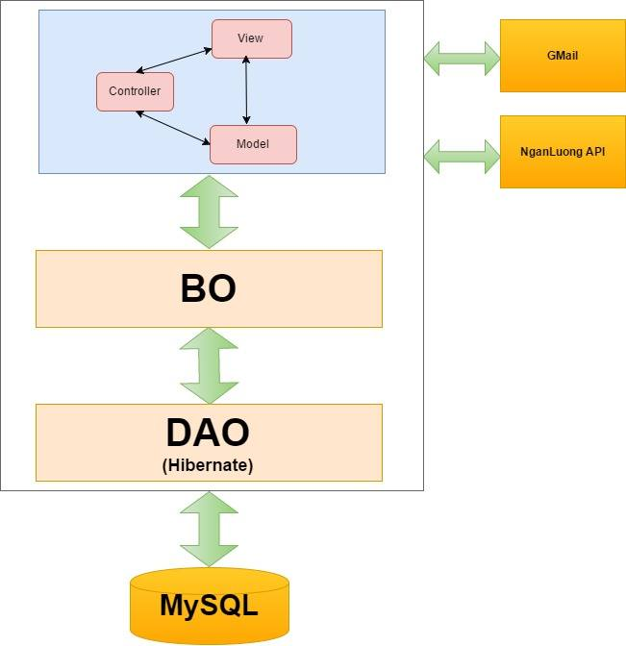

Figure 1 Architecture Overview

# DETAILED DESIGN

## Common Class Description

### BaseBean

|  |  |  |  |  |
| --- | --- | --- | --- | --- |
| Class | BaseBean | | | |
| **Description** | Common class for Decision Center beans | | | |
| **Base Class** | N/A | | | |
| **Constructor** | BaseBean() | | | |
| **Prototype** | N/A | | | |
| **Source File** | BaseBean.java | | | |
| **Namespace** | vn.co.cex.bean | | | |
| **Methods** | Name | Input | Output | Description |
| getHTTPRequest() |  | HttpServletRequest |  |
| getHTTPResponse() |  | HttpServletResponse |  |

### BaseBO

|  |  |
| --- | --- |
| Class | BaseBO |
| **Description** | An interface of BaseBOImpl |
| **Base Class** | N/A |
| **Constructor** | N/A |
| **Prototype** | N/A |
| **Source File** | BaseBO.java |
| **Namespace** | vn.co.cex.bo |

### BaseBOImpl

|  |  |  |  |  |
| --- | --- | --- | --- | --- |
| Class | BaseBOImpl | | | |
| **Description** | Object manages the mapping details between a set of objects and underlying relational databases. | | | |
| **Base Class** | N/A | | | |
| **Constructor** | BaseBOImpl() | | | |
| **Prototype** | N/A | | | |
| **Source File** | BaseBOImpl.java | | | |
| **Namespace** | vn.co.cex.bo.Impl | | | |
| **Methods** | Name | Input | Output | Description |
| getCompanyDAO() |  | CompanyDAO |  |
| setCompanyDAO(CompanyDAO) | CompanyDAO |  |  |
| getMailerBean() |  | MailerBean |  |
| setMailerBean(MailerBean) | MailerBean |  |  |
| getUsersDAO() |  | UsersDAO |  |
| setUsersDAO(UsersDAO) | UsersDAO |  |  |
| getReportDAO() |  | ReportDAO |  |
| setReportDAO(ReportDAO) | ReportDAO |  |  |
| getBillOfLadingDAO() |  | BillOfLadingDAO |  |
| setBillOfLadingDAO(BillOfLadingDAO) | BillOfLadingDAO |  |  |
| getGoodsTypeDAO() |  | GoodsTypeDAO |  |
| setGoodsTypeDAO(GoodsTypeDAO) | GoodsTypeDAO |  |  |
| getPackagedFormDAO() |  | PackagedFormDAO |  |
| setPackagedFormDAO(PackagedFormDAO) | PackagedFormDAO |  |  |
| getProvinceDAO() |  | ProvinceDAO |  |
| setProvinceDAO(ProvinceDAO) | ProvinceDAO |  |  |
| getDistrictDAO() |  | DistrictDAO |  |
| setDistrictDAO(DistrictDAO) | DistrictDAO |  |  |
| getOperationFeeDAO() |  | OperationFeeDAO |  |
| setOperationFeeDAO(OperationFeeDAO) | OperationFeeDAO |  |  |
| getCarrierAuctionDAO() |  | CarrierAuctionDAO |  |
| setCarrierAuctionDAO(CarrierAuctionDAO) | CarrierAuctionDAO |  |  |
| getCommentDAO() |  | CommentDAO |  |
| setCommentDAO(CommentDAO) | CommentDAO |  |  |
| getUsersAccountDAO() |  | UsersAccountDAO |  |
| setUsersAccountDAO(UsersAccountDAO) | UsersAccountDAO |  |  |
| getPaymentDetailDAO() |  | PaymentDetailDAO |  |
| setPaymentDetailDAO(PaymentDetailDAO) | PaymentDetailDAO |  |  |

|  |  |  |  |
| --- | --- | --- | --- |
| Class | BaseBOImpl | | |
| **Description** | Object manages the mapping details between a set of objects and underlying relational databases. | | |
| **Base Class** | N/A | | |
| **Constructor** | BaseBOImpl() | | |
| **Prototype** | N/A | | |
| **Source File** | BaseBOImpl.java | | |
| **Namespace** | vn.co.cex.bo.impl | | |
|  |  | | |
| **Attributes** | Name | Type | Description |
| Id | Integer |  |
| FullName | String |  |
| Email | String |  |
| Password | String |  |
| PhoneNumber | String |  |
| address | String |  |
| identityCard | String |  |
| identityCardPlace | String |  |
| identityCardDate | Date |  |
| identityCardImage | String |  |
| role | int |  |
| status | int |  |
| created | Date |  |
| companyId | Integer |  |
| userAvatar | String |  |

### BaseDAO

|  |  |  |  |  |
| --- | --- | --- | --- | --- |
| Class | BaseDAO | | | |
| **Description** | An interface of BaseDAOImpl | | | |
| **Base Class** | N/A | | | |
| **Constructor** | N/A | | | |
| **Prototype** | N/A | | | |
| **Source File** | BaseDAO.java | | | |
| **Namespace** | vn.co.cex.dao | | | |
| **Methods** | Name | Input | Output | Description |
| update(Object) | Object |  |  |
| insert(Object) | Object |  |  |
| delete(Object) | Object |  |  |

### BaseDAOImpl

|  |  |  |  |  |
| --- | --- | --- | --- | --- |
| Class | BaseDAOImpl | | | |
| **Description** | An Object used to access data from database of data storage. | | | |
| **Base Class** | N/A | | | |
| **Constructor** | N/A | | | |
| **Prototype** | N/A | | | |
| **Source File** | BaseDAOImpl.java | | | |
| **Namespace** | vn.co.cex.dao.impl | | | |
| **Methods** | Name | Input | Output | Description |
| update(Object) | Object |  |  |
| insert(Object) | Object |  |  |
| delete(Object) | Object |  |  |

### Users

|  |  |  |  |
| --- | --- | --- | --- |
| Class | Users | | |
| **Description** | User Object manages the mapping details between a set of objects and underlying relational databases. | | |
| **Base Class** | N/A | | |
| **Constructor** | Users(String fullName, String email, String password, String phoneNumber, String address, String districtCode, String identityCard, String identityCardPlace, Date, identityCardDate, String identityCardImage, **int** role, **int** status, Date created, Integer companyId, String userAvatar) | | |
| **Prototype** | N/A | | |
| **Source File** | Users.java | | |
| **Namespace** | vn.co.cex.orm | | |
| **Attributes** | Name | Type | Description |
| id | Integer |  |
| fullName | String |  |
| email | String |  |
| password | String |  |
| phoneNumber | String |  |
| address | String |  |
| identityCard | String |  |
| identityCardPlace | String |  |
| identityCardDate | Date |  |
| identityCardImage | String |  |
| role | int |  |
| status | int |  |
| created | Date |  |
| companyId | Integer |  |
| userAvatar | String |  |

### UsersBO

|  |  |  |  |  |
| --- | --- | --- | --- | --- |
| Class | UsersBO | | | |
| **Description** | An interface of UsersBOImpl | | | |
| **Base Class** | BaseBO | | | |
| **Constructor** | BaseBean() | | | |
| **Prototype** | N/A | | | |
| **Source File** | UsersBO.java | | | |
| **Namespace** | vn.co.cex.bo | | | |
| **Methods** | Name | Input | Output | Description |
| getUserById(int) | Id | Users |  |
| checkLogin(String, String) | Email, Password | Users |  |
| updateUsers(Users) | Users | Boolean |  |
| getUserByEmail(String) | Email | Users |  |
| register(Users) | Users | int |  |
| checkEmail(String) | Email | Boolean |  |
| checkPhoneNumber(String) | Phone no | Boolean |  |
| checkIdentityCard(String) | Identity card number | Boolean |  |
| searchUser(String, String, String, Integer, int, int, int) | fullName, email, province, role, status | List<Users> |  |
| countUsers(String, String, String, Integer, int) | fullName, email, province, role, status | Int |  |
| activateUser(int) | Id |  |  |
| deactivateUser(int) | Id |  |  |

### UsersBOImpl

|  |  |  |  |  |
| --- | --- | --- | --- | --- |
| Class | UsersBOImpl | | | |
| **Description** | User Object manages the mapping details between a set of objects and underlying relational databases. | | | |
| **Base Class** | BaseBOImpl | | | |
| **Constructor** | BaseBean() | | | |
| **Prototype** | N/A | | | |
| **Source File** | UsersBOImpl.java | | | |
| **Namespace** | vn.co.cex.bo.impl | | | |
| **Methods** | Name | Input | Output | Description |
| getUserById(int) | Id | Users |  |
| checkLogin(String, String) | Email, Password | Users |  |
| updateUsers(Users) | Users | Boolean |  |
| getUserByEmail(String) | Email | Users |  |
| register(Users) | Users | int |  |
| checkEmail(String) | Email | Boolean |  |
| checkPhoneNumber(String) | Phone no | Boolean |  |
| checkIdentityCard(String) | Identity card number | Boolean |  |
| searchUser(String, String, String, Integer, int, int, int) | fullName, email, province, role, status | List<Users> |  |
| countUsers(String, String, String, Integer, int) | fullName, email, province, role, status | Int |  |
| activateUser(int) | Id |  |  |
| deactivateUser(int) | Id |  |  |

### UsersDAO

|  |  |  |  |  |
| --- | --- | --- | --- | --- |
| Class | UsersDAO | | | |
| **Description** | An interface of UsersDAOImpl | | | |
| **Base Class** | BaseDAO | | | |
| **Constructor** | N/A | | | |
| **Prototype** | N/A | | | |
| **Source File** | UsersDAO.java | | | |
| **Namespace** | vn.co.cex.dao | | | |
| **Methods** | Name | Input | Output | Description |
| getUserById(int) | Id | Users |  |
| checkLogin(String, String) | Email, Password | Users |  |
| updateUsers(Users) | Users | Boolean |  |
| getUserByEmail(String) | Email | Users |  |
| register(Users) | Users | int |  |
| checkEmail(String) | Email | Boolean |  |
| checkPhoneNumber(String) | Phone no | Boolean |  |
| checkIdentityCard(String) | Identity card number | Boolean |  |
| searchUser(String, String, String, Integer, int, int, int) | fullName, email, province, role, status | List<Users> |  |
| countUsers(String, String, String, Integer, int) | fullName, email, province, role, status | Int |  |
| activateUser(int) | Id |  |  |
| deactivateUser(int) | Id |  |  |

### UsersDAOImpl

|  |  |  |  |  |
| --- | --- | --- | --- | --- |
| Class | UsersDAOImpl | | | |
| **Description** | Access the Database and Do the business logic. | | | |
| **Base Class** | BaseDAOImpl | | | |
| **Constructor** | N/A | | | |
| **Prototype** | N/A | | | |
| **Source File** | UsersDAO.java | | | |
| **Namespace** | vn.co.cex.dao.impl | | | |
| **Methods** | Name | Input | Output | Description |
| getUserById(int) | Id | Users |  |
| checkLogin(String, String) | Email, Password | Users |  |
| updateUsers(Users) | Users | Boolean |  |
| getUserByEmail(String) | Email | Users |  |
| register(Users) | Users | int |  |
| checkEmail(String) | Email | Boolean |  |
| checkPhoneNumber(String) | Phone no | Boolean |  |
| checkIdentityCard(String) | Identity card number | Boolean |  |
| searchUser(String, String, String, Integer, int, int, int) | fullName, email, province, role, status | List<Users> |  |
| countUsers(String, String, String, Integer, int) | fullName, email, province, role, status | Int |  |
| activateUser(int) | Id |  |  |
| deactivateUser(int) | Id |  |  |

### OperationFee

|  |  |  |  |
| --- | --- | --- | --- |
| Class | OperationFee | | |
| **Description** | OpearationFee Object manages the mapping details between a set of objects and underlying relational databases. | | |
| **Base Class** | N/A | | |
| **Constructor** | OperationFee(Integer id, String code, String feeName, **boolean** type, Float fee, Float percent, String description, **int** status, Date modified, Date created) | | |
| **Prototype** | N/A | | |
| **Source File** | OperationFee.java | | |
| **Namespace** | vn.co.cex.orm | | |
| **Attributes** | Name | Type | Description |
| id | Integer |  |
| code | String |  |
| feeName | String |  |
| type | boolean |  |
| fee | Float |  |
| percent | Float |  |
| description | String |  |
| status | int |  |

### OperationFeeBO

|  |  |  |  |  |
| --- | --- | --- | --- | --- |
| Class | OperationFeeBO | | | |
| **Description** | An interface of OperationFeeBOImpl | | | |
| **Base Class** | BaseBO | | | |
| **Constructor** | N/A | | | |
| **Prototype** | N/A | | | |
| **Source File** | OperationFeeBO.java | | | |
| **Namespace** | vn.co.cex.bo | | | |
| **Methods** | Name | Input | Output | Description |
| getAllOperationFee(Integer) | Status | List<OperationFe> |  |
| addNewOperationFee(OperationFee) | OperationFee | boolean |  |
| updateOperationFee(OperationFee) | OperationFee | boolean |  |
| getOperationFeeById(int) | id | OperationFee |  |
| getOperationFeeByCode(String) | code | OperationFee |  |

### OperationFeeBOImpl

|  |  |  |  |  |
| --- | --- | --- | --- | --- |
| Class | OperationFeeBOImpl | | | |
| **Description** | Do the business logic by calling OpeartionFeeDAO. | | | |
| **Base Class** | BaseBO | | | |
| **Constructor** | N/A | | | |
| **Prototype** | N/A | | | |
| **Source File** | OperationFeeBO.java | | | |
| **Namespace** | vn.co.cex.bo | | | |
| **Methods** | Name | Input | Output | Description |
| getAllOperationFee(Integer) | Status | List<OperationFe> |  |
| addNewOperationFee(OperationFee) | OperationFee | boolean |  |
| updateOperationFee(OperationFee) | OperationFee | boolean |  |
| getOperationFeeById(int) | id | OperationFee |  |
| getOperationFeeByCode(String) | code | OperationFee |  |

### OperationFeeDAO

|  |  |  |  |  |
| --- | --- | --- | --- | --- |
| Class | OperationFeeDAO | | | |
| **Description** | An interface of OperationFeeDAOImpl | | | |
| **Base Class** | BaseDAO | | | |
| **Constructor** | N/A | | | |
| **Prototype** | N/A | | | |
| **Source File** | OperationFeeDAO.java | | | |
| **Namespace** | vn.co.cex.dao | | | |
| **Methods** | Name | Input | Output | Description |
| getAllOperationFee(Integer) | Status | List<OperationFe> |  |
| addNewOperationFee(OperationFee) | OperationFee | boolean |  |
| updateOperationFee(OperationFee) | OperationFee | boolean |  |
| getOperationFeeById(int) | id | OperationFee |  |
| getOperationFeeByCode(String) | code | OperationFee |  |

### OperationFeeDAOImpl

|  |  |  |  |  |
| --- | --- | --- | --- | --- |
| Class | OperationFeeDAOImpl | | | |
| **Description** | Access the Database and Do the business logic. | | | |
| **Base Class** | BaseDAOImpl | | | |
| **Constructor** | N/A | | | |
| **Prototype** | N/A | | | |
| **Source File** | OperationFeeDAOImpl.java | | | |
| **Namespace** | vn.co.cex.dao.impl | | | |
| **Methods** | Name | Input | Output | Description |
| getAllOperationFee(Integer) | Status | List<OperationFe> |  |
| addNewOperationFee(OperationFee) | OperationFee | boolean |  |
| updateOperationFee(OperationFee) | OperationFee | boolean |  |
| getOperationFeeById(int) | id | OperationFee |  |
| getOperationFeeByCode(String) | code | OperationFee |  |

## Guest register a new account

### Class Diagram



Figure 2 Register Class Diagram

### Class Description

#### RegisterBean

|  |  |  |  |  |
| --- | --- | --- | --- | --- |
| Class | RegisterBean | | | |
| **Description** | Register an user | | | |
| **Base Class** | BaseBean | | | |
| **Constructor** | N/A | | | |
| **Prototype** | N/A | | | |
| **Source File** | RegisterBean.java | | | |
| **Namespace** | vn.co.cex.bean.login | | | |
| **Attributes** | Name | Type | Description | |
| FullName | String |  | |
| Email | String |  | |
| Password | String |  | |
| PhoneNumber | String |  | |
| address | String |  | |
| identityCard | String |  | |
| identityCardPlace | String |  | |
| identityCardDate | Date |  | |
| identityCardImage | String |  | |
| role | int |  | |
| status | int |  | |
| created | Date |  | |
| companyId | Integer |  | |
| userAvatar | String |  | |
| **Methods** | Name | Input | Output | Description |
| registerUser() |  | String |  |
| sendMailRegister(Users) | Users |  |  |

### Screen Design

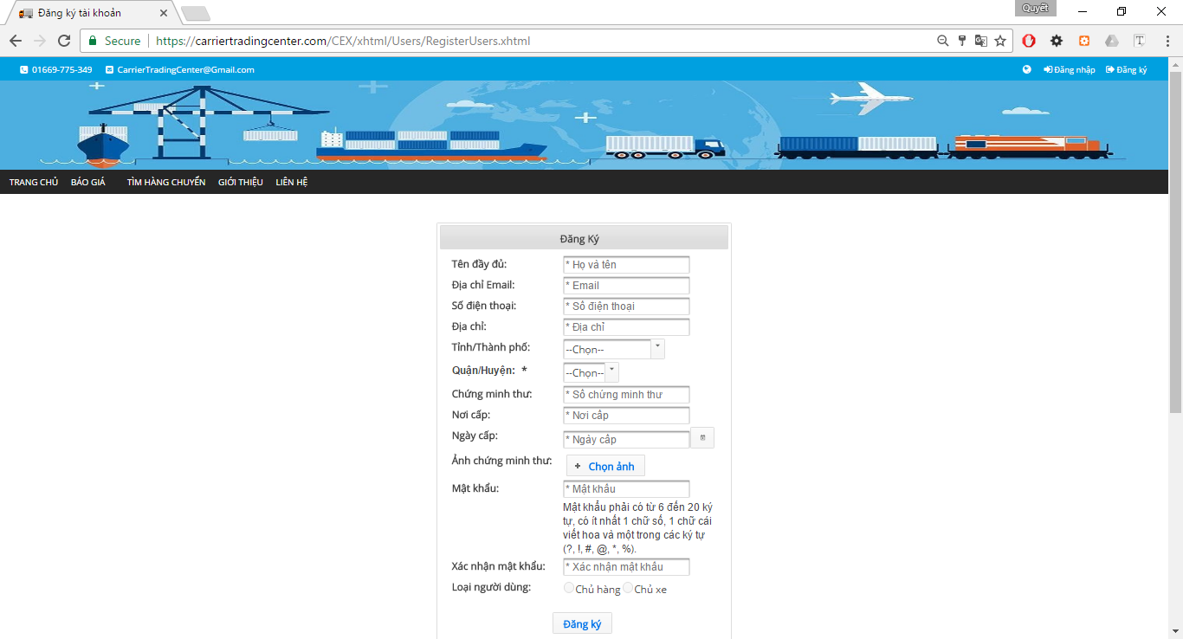

Figure 3 Register

**Table 2-2** Register

|  |  |  |  |  |  |  |
| --- | --- | --- | --- | --- | --- | --- |
| **No** | **Object/Control Name** | **Object/Control Name in English** | **Type** | **Required** | **Length** | **Description** |
| 1. 11 | Tên đầy đủ | fullName | inputText | Yes | 50 |  |
| 2 | Địa chỉ Emaill | email | inputText | Yes | 50 |  |
| 3 | Số điện thoại | phonenNmber | inputText | Yes | 20 |  |
|  | Địa chỉ | Address | inputText | Yes | 100 |  |
|  | Tỉnh/Thành phố | province | selectOneMenu | Yes | 50 |  |
|  | Quận/Huyện | district | selectOneMenu | Yes | 50 |  |
|  | Chứng minh thư | identityCard | inputText | Yes | 20 |  |
|  | Nơi cấp | identityCardPlace | inputText | Yes | 100 |  |
|  | Ngày cấp | identityCardDate | calendar | Yes |  |  |
|  | Ảnh chứng minh thư | identityCardImage | fileUpload | Yes |  |  |
|  | Mật khẩu | password | password | Yes | 50 |  |
|  | Xác nhận mật khẩu | reEnterPassword | password | Yes | 50 |  |
|  | Loại người dùng | role | selectOneRadio | Yes |  |  |
|  | Đăng ký | register | commandButton |  |  |  |

### Sequence Diagram



Figure 4 Register Sequence Diagram

## Guest reference price

### Class Diagram

### Class Description

### Screen Design

### Sequence Diagram

## Guest view price

### Class Diagram



Figure 5 Operation Fee Class Diagram

### Class Description

#### OperationFeeBean

|  |  |  |  |  |
| --- | --- | --- | --- | --- |
| Class | OperationFeeBean | | | |
| **Description** | Show Operation fee. | | | |
| **Base Class** | BaseBean | | | |
| **Constructor** | N/A | | | |
| **Prototype** | N/A | | | |
| **Source File** | OperationFeeBean.java | | | |
| **Namespace** | vn.co.cex.bean.operationfee | | | |
| **Attributes** | Name | Type | Description | |
| operationFees | List<OpẻationFee> |  | |
| status | Integer |  | |
| **Methods** | Name | Input | Output | Description |
| getOperationFeeBO() |  | OperationFeeBO |  |
| setOperationFeeBO(OperationFeeBO) |  |  |  |
| getOperationFees() |  | List<OperationFee> |  |
| setOperationFees(List<OperationFee>) |  |  |  |
| getStatus() |  | Integer |  |
| setStatus(Integer) |  |  |  |
| searchOperationFee() |  |  |  |

### Screen Design



Figure 6 View Price

**Table 2-4** ListOperationFee

|  |  |  |  |  |  |  |
| --- | --- | --- | --- | --- | --- | --- |
| **No** | **Object/Control Name** | **Object/Control Name in English** | **Type** | **Required** | **Length** | **Description** |
| 1. 11 | Danh sách các khoản phí | feeDataTable | dataTable |  |  |  |

### Sequence Diagram



Figure 7 Operation Fee Sequence Diagram

## Guest search bill of lading

### Class Diagram



### Class Description

#### CommonBean

|  |  |  |  |  |
| --- | --- | --- | --- | --- |
| Class | CommonBean | | | |
| **Description** | Show bill of lading and search bill of lading. | | | |
| **Base Class** | BaseBean | | | |
| **Constructor** | N/A | | | |
| **Prototype** | N/A | | | |
| **Source File** | CommonBean.java | | | |
| **Namespace** | vn.co.cex.bean.billoflading | | | |
| **Attributes** | Name | Type | Description | |
| goodsTypeId | Integer |  | |
| packagedFormId | Integer |  | |
| weight | Float |  | |
| volume | Float |  | |
| departureProvinceCode | String |  | |
| arrivalProvinceCode | String |  | |
| status | Integer |  | |
| timeRemaining | int |  | |
| **Methods** | Name | Input | Output | Description |
| searchBillOfLading() |  |  |  |

### Screen Design

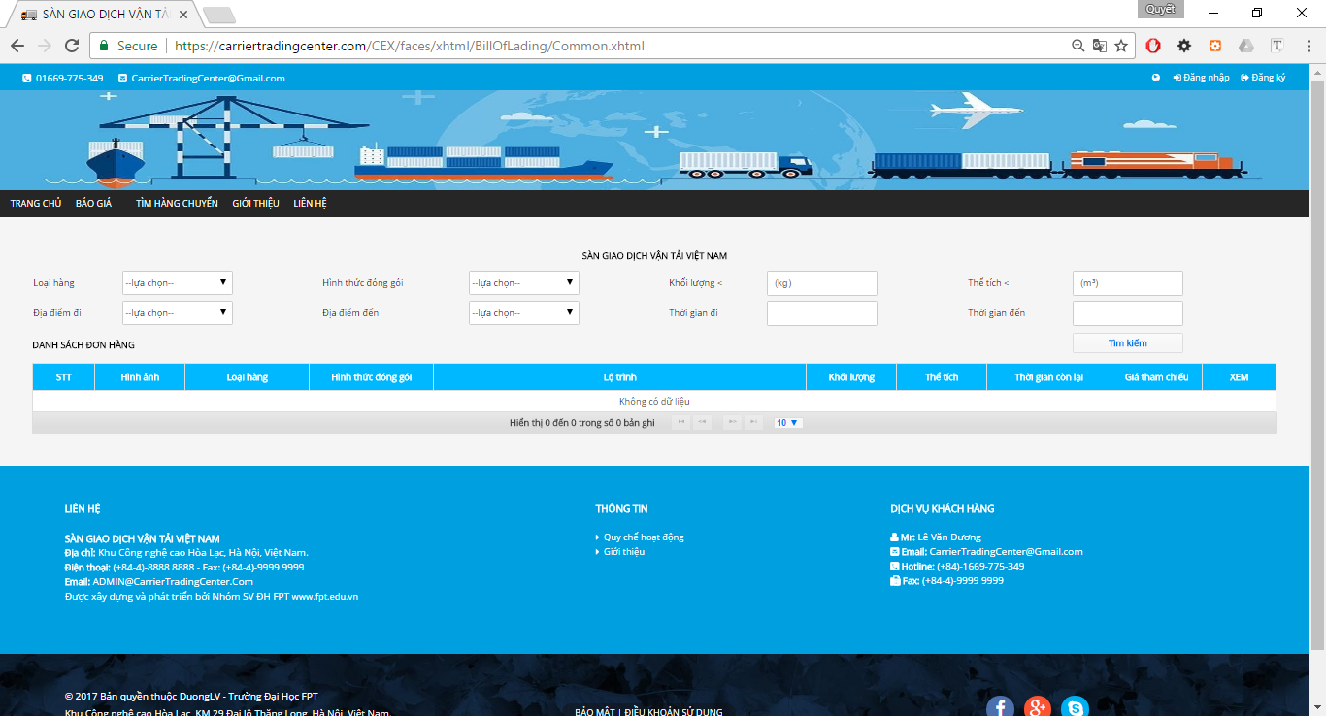

Figure 8 Search Bill of Lading

**Table 2-5** Search Bills of Lading

|  |  |  |  |  |  |  |
| --- | --- | --- | --- | --- | --- | --- |
| **No** | **Object/Control Name** | **Object/Control Name in English** | **Type** | **Required** | **Length** | **Description** |
| 1. 11 | Loại Hàng | goodTypeId | selectOneMenu | No |  |  |
| 2 | Hình thức đóng gói | packageFormId | selectOneMenu | No |  |  |
| 3 | Khối lượng | weight | inputText | No |  |  |
|  | Thể tích | volume | inputText | No |  |  |
|  | Địa điểm đi | slbDepartureProvinceID | selectOneMenu | No |  |  |
|  | Địa điêm đến | slbArrivalProvinceID | selectOneMenu | No |  |  |
|  | Thời gian đi | departureDate | calendar | No |  |  |
|  | Thời gian đến | arrivalDate | calendar | No |  |  |
|  | Tìm kiếm | search | commandButton |  |  |  |
|  | Danh sách đơn hàng | table_billoflading | dataTable |  |  |  |

### Sequence Diagram



Figure 9 Search Bill of Lading Sequence Diagram

## Guest view list bill of lading

### Class Diagram



Figure 10 View List Bill of Lading

### Class Description

#### CommonBean

|  |  |  |  |  |
| --- | --- | --- | --- | --- |
| Class | CommonBean | | | |
| **Description** | Show bill of lading and search bill of lading. | | | |
| **Base Class** | BaseBean | | | |
| **Constructor** | N/A | | | |
| **Prototype** | N/A | | | |
| **Source File** | CommonBean.java | | | |
| **Namespace** | vn.co.cex.bean.billoflading | | | |
| **Attributes** | Name | Type | Description | |
| goodsTypeId | Integer |  | |
| packagedFormId | Integer |  | |
| weight | Float |  | |
| volume | Float |  | |
| departureProvinceCode | String |  | |
| arrivalProvinceCode | String |  | |
| status | Integer |  | |
| timeRemaining | int |  | |
| **Methods** | Name | Input | Output | Description |
| searchBillOfLading() |  |  |  |

### Screen Design



Figure 11 Bills of Lading

**Table 2-6** Bills of Lading

|  |  |  |  |  |  |  |
| --- | --- | --- | --- | --- | --- | --- |
| **No** | **Object/Control Name** | **Object/Control Name in English** | **Type** | **Required** | **Length** | **Description** |
| 1. 11 | Loại Hàng | goodTypeId | selectOneMenu | No |  |  |
| 2 | Hình thức đóng gói | packageFormId | selectOneMenu | No |  |  |
| 3 | Khối lượng | weight | inputText | No |  |  |
|  | Thể tích | volume | inputText | No |  |  |
|  | Địa điểm đi | slbDepartureProvinceID | selectOneMenu | No |  |  |
|  | Địa điêm đến | slbArrivalProvinceID | selectOneMenu | No |  |  |
|  | Thời gian đi | departureDate | calendar | No |  |  |
|  | Thời gian đến | arrivalDate | calendar | No |  |  |
|  | Tìm kiếm | search | commandButton |  |  |  |
|  | Danh sách đơn hàng | table_billoflading | dataTable |  |  |  |

### Sequence Diagram



Figure 12 View Bill of Lading Sequence Diagram

## Admin view user list

### Class Diagram



Figure 13 Users List Class Diagram

### Class Description

#### UsersBean

|  |  |  |  |
| --- | --- | --- | --- |
| Class | UsersBean | | |
| **Description** | Show List Users. | | |
| **Base Class** | BaseBean | | |
| **Constructor** | N/A | | |
| **Prototype** | N/A | | |
| **Source File** | UsersBean.java | | |
| **Namespace** | vn.co.cex.bean.users | | |
| **Attributes** | Name | Type | Description |
| id | Integer |  |
| code | String |  |
| fullName | String |  |
| email | String |  |
| password | String |  |
| phoneNumber | String |  |
| address | String |  |
| province | String |  |
| district | String |  |
| identityCard | String |  |
| identityCardPlace | String |  |
| role | Integer |  |
| status | int |  |
| companyId | Integer |  |

### Screen Design



**Table 2-7** List users

|  |  |  |  |  |  |  |
| --- | --- | --- | --- | --- | --- | --- |
| **No** | **Object/Control Name** | **Object/Control Name in English** | **Type** | **Required** | **Length** | **Description** |
| 1. 11 | Tên người dung | fullName | inputText | No |  |  |
| 2 | Email | email | inputText | No |  |  |
| 3 | Tỉnh | province | selectOneMenu | No |  |  |
|  | Quyền truy cập | role | selectOneMenu | No |  |  |
|  | Tìm kiếm | btn_search | btn_search |  |  |  |
|  | Danh sách người dùng | table_users | table_users |  |  |  |

### Sequence Diagram



Figure 14 Users List Class Diagram

## Admin Summary all Bill of Lading

### Class Diagram



Figure 15 Summary all Bills Of Lading

### Class Description

#### SummaryBillOfLadingBean

|  |  |  |  |  |
| --- | --- | --- | --- | --- |
| Class | SummaryBillOfLadingBean | | | |
| **Description** | Show summary bill of lading. | | | |
| **Base Class** | BaseBean | | | |
| **Constructor** | N/A | | | |
| **Prototype** | N/A | | | |
| **Source File** | SummaryBillOfLadingBean.java | | | |
| **Namespace** | vn.co.cex.bean.admin | | | |
| **Attributes** | Name | Type | Description | |
| goodsTypeId | Integer |  | |
| packagedFormId | Integer |  | |
| weight | Float |  | |
| volume | Float |  | |
| departureProvinceCode | String |  | |
| arrivalProvinceCode | String |  | |
| **Methods** | Name | Input | Output | Description |
| searchBillOfLading() |  |  |  |

### Screen Design

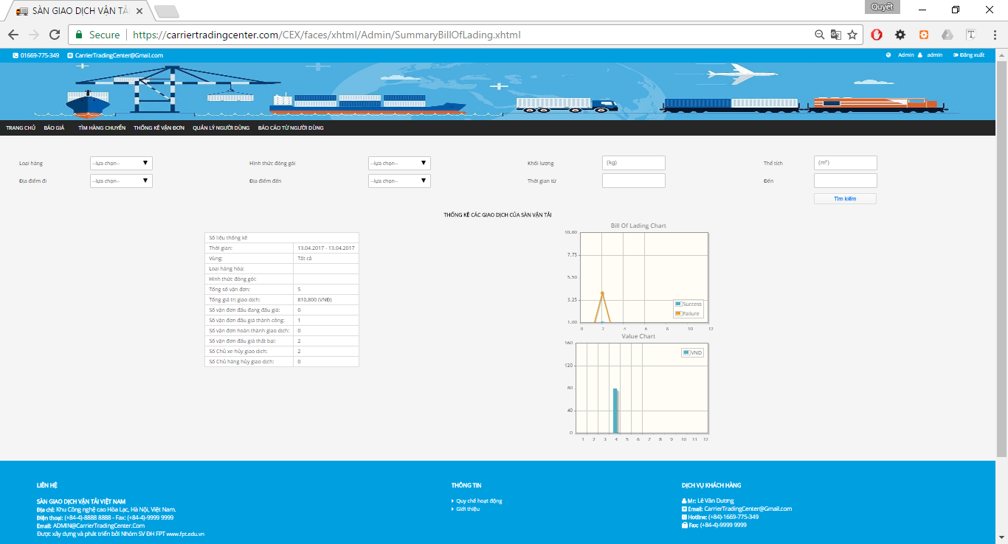

**Table 2-8** Summary bills of lading

|  |  |  |  |  |  |  |
| --- | --- | --- | --- | --- | --- | --- |
| **No** | **Object/Control Name** | **Object/Control Name in English** | **Type** | **Required** | **Length** | **Description** |
| 1. 11 | Loại Hàng | goodTypeId | selectOneMenu | No |  |  |
| 2 | Hình thức đóng gói | packageFormId | selectOneMenu | No |  |  |
| 3 | Khối lượng | weight | inputText | No |  |  |
|  | Thể tích | volume | inputText | No |  |  |
|  | Địa điểm đi | slbDepartureProvinceID | selectOneMenu | No |  |  |
|  | Địa điêm đến | slbArrivalProvinceID | selectOneMenu | No |  |  |
|  | Thời gian từ | departureDate | calendar | No |  |  |
|  | Đến | arrivalDate | calendar | No |  |  |
|  | Tìm kiếm | search | commandButton |  |  |  |
|  | Thống kê giao dịch | billoflading_summary | dataTable |  |  |  |
|  | Biêu đồ thống kê giao dịch | billof LadingChart | chart |  |  |  |
|  | Biểu đồ giá trị giao dịch | valueChart | chart |  |  |  |

### Sequence Diagram



Figure 16 Summary Bills of Lading Sequence Diagram

## Admin view list bill of lading

### Class Diagram



Figure 17 View List Bill of Lading Class Diagram

### Class Description

#### CommonBean

|  |  |  |  |  |
| --- | --- | --- | --- | --- |
| Class | CommonBean | | | |
| **Description** | Show bill of lading and search bill of lading. | | | |
| **Base Class** | BaseBean | | | |
| **Constructor** | N/A | | | |
| **Prototype** | N/A | | | |
| **Source File** | CommonBean.java | | | |
| **Namespace** | vn.co.cex.bean.billoflading | | | |
| **Attributes** | Name | Type | Description | |
| goodsTypeId | Integer |  | |
| packagedFormId | Integer |  | |
| weight | Float |  | |
| volume | Float |  | |
| departureProvinceCode | String |  | |
| arrivalProvinceCode | String |  | |
| status | Integer |  | |
| timeRemaining | int |  | |
| **Methods** | Name | Input | Output | Description |
| searchBillOfLading() |  |  |  |

### Screen Design

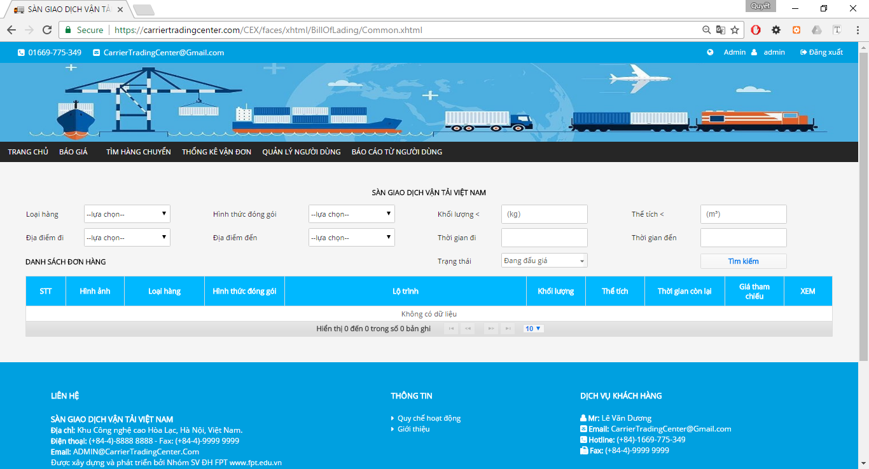

Figure 18 Admin View List Bills of Lading

**Table 2-9** Bills of Lading

|  |  |  |  |  |  |  |
| --- | --- | --- | --- | --- | --- | --- |
| **No** | **Object/Control Name** | **Object/Control Name in English** | **Type** | **Required** | **Length** | **Description** |
| 1. 11 | Loại Hàng | goodTypeId | selectOneMenu | No |  |  |
| 2 | Hình thức đóng gói | packageFormId | selectOneMenu | No |  |  |
| 3 | Khối lượng | weight | inputText | No |  |  |
|  | Thể tích | volume | inputText | No |  |  |
|  | Địa điểm đi | slbDepartureProvinceID | selectOneMenu | No |  |  |
|  | Địa điêm đến | slbArrivalProvinceID | selectOneMenu | No |  |  |
|  | Thời gian đi | departureDate | calendar | No |  |  |
|  | Thời gian đến | arrivalDate | calendar | No |  |  |
|  | Trạng thái | status | selectOneMenu | No |  |  |
|  | Tìm kiếm | search | commandButton |  |  |  |
|  | Danh sách đơn hàng | table_billoflading | dataTable |  |  |  |

### Sequence Diagram



## Admin Search Bill of Lading

### Class Diagram



Figure 19 Search Bills of Lading Class Diagram

### Class Description

#### CommonBean

|  |  |  |  |  |
| --- | --- | --- | --- | --- |
| Class | CommonBean | | | |
| **Description** | Show bill of lading and search bill of lading. | | | |
| **Base Class** | BaseBean | | | |
| **Constructor** | N/A | | | |
| **Prototype** | N/A | | | |
| **Source File** | CommonBean.java | | | |
| **Namespace** | vn.co.cex.bean.billoflading | | | |
| **Attributes** | Name | Type | Description | |
| goodsTypeId | Integer |  | |
| packagedFormId | Integer |  | |
| weight | Float |  | |
| volume | Float |  | |
| departureProvinceCode | String |  | |
| arrivalProvinceCode | String |  | |
| status | Integer |  | |
| timeRemaining | int |  | |
| **Methods** | Name | Input | Output | Description |
| searchBillOfLading() |  |  |  |

### Screen Design



Figure 20 Admin List View Bills of Lading

**Table 2-10** Bills of Lading

|  |  |  |  |  |  |  |
| --- | --- | --- | --- | --- | --- | --- |
| **No** | **Object/Control Name** | **Object/Control Name in English** | **Type** | **Required** | **Length** | **Description** |
| 1. 11 | Loại Hàng | goodTypeId | selectOneMenu | No |  |  |
| 2 | Hình thức đóng gói | packageFormId | selectOneMenu | No |  |  |
| 3 | Khối lượng | weight | inputText | No |  |  |
|  | Thể tích | volume | inputText | No |  |  |
|  | Địa điểm đi | slbDepartureProvinceID | selectOneMenu | No |  |  |
|  | Địa điêm đến | slbArrivalProvinceID | selectOneMenu | No |  |  |
|  | Thời gian đi | departureDate | calendar | No |  |  |
|  | Thời gian đến | arrivalDate | calendar | No |  |  |
|  | Trạng thái | status | selectOneMenu | No |  |  |
|  | Tìm kiếm | search | commandButton |  |  |  |
|  | Danh sách đơn hàng | table_billoflading | dataTable |  |  |  |

### Sequence Diagram



Figure 21 Search Bills of Lading Sequence Diagram

## Admin View Bill of Lading Detail

### Class Diagram



Figure 22 View Detail Bill of Lading Class Diagram

### Class Description

#### BillOfLadingDetailBean

|  |  |  |  |  |
| --- | --- | --- | --- | --- |
| Class | BillOfLadingDetailBean | | | |
| **Description** | Show detail bill of lading. | | | |
| **Base Class** | BaseBean | | | |
| **Constructor** | N/A | | | |
| **Prototype** | N/A | | | |
| **Source File** | BillOfLadingDetailBean.java | | | |
| **Namespace** | vn.co.cex.bean.billoflading | | | |
| **Methods** | Name | Input | Output | Description |
| auction(int) | billofLadingId |  |  |
| goodsOwnerCancelAuction() |  |  |  |
| carrierCancelAuction() |  |  |  |
| confirmCompleted() |  |  |  |
| writeComment() |  |  |  |
| writeAnswerComment(int) | commentId |  |  |
| updateComment() |  |  |  |

### Screen Design



Figure 23 Detail Bill of Lading (part 1)



Figure 24 Detail Bill of Lading (part 2)

**Table 2-11** Detail Bills of Lading

|  |  |  |  |  |  |  |
| --- | --- | --- | --- | --- | --- | --- |
| **No** | **Object/Control Name** | **Object/Control Name in English** | **Type** | **Required** | **Length** | **Description** |
| 1. 11 | Thông tin hàng hóa cần vận chuyển | good_information | panelGrid |  |  |  |
| 2 | Gmap | gmap | Java script |  |  |  |
| 3 | Danh sách chủ xe đấu thầu | tableCarrierAuctionList | dataTable |  |  |  |
|  | Hỏi đáp | question_answer | PanelGroup | No |  |  |

### Sequence Diagram



Figure 25 Bill of Lading Detail Sequence Diagram

## Admin view list of carrier who are auctioning

### Class Diagram



Figure 26 List Bill of Lading Auctioning Class Diagram

### Class Description

#### CommonBean

|  |  |  |  |  |
| --- | --- | --- | --- | --- |
| Class | CommonBean | | | |
| **Description** | Show bill of lading and search bill of lading. | | | |
| **Base Class** | BaseBean | | | |
| **Constructor** | N/A | | | |
| **Prototype** | N/A | | | |
| **Source File** | CommonBean.java | | | |
| **Namespace** | vn.co.cex.bean.billoflading | | | |
| **Attributes** | Name | Type | Description | |
| goodsTypeId | Integer |  | |
| packagedFormId | Integer |  | |
| weight | Float |  | |
| volume | Float |  | |
| departureProvinceCode | String |  | |
| arrivalProvinceCode | String |  | |
| status | Integer |  | |
| timeRemaining | int |  | |
| **Methods** | Name | Input | Output | Description |
| searchBillOfLading() |  |  |  |

### Screen Design



Figure 27 List Bill of Lading Auctioning

**Table 2-12** Bills of Lading

|  |  |  |  |  |  |  |
| --- | --- | --- | --- | --- | --- | --- |
| **No** | **Object/Control Name** | **Object/Control Name in English** | **Type** | **Required** | **Length** | **Description** |
| 1. 11 | Loại Hàng | goodTypeId | selectOneMenu | No |  |  |
| 2 | Hình thức đóng gói | packageFormId | selectOneMenu | No |  |  |
| 3 | Khối lượng | weight | inputText | No |  |  |
|  | Thể tích | volume | inputText | No |  |  |
|  | Địa điểm đi | slbDepartureProvinceID | selectOneMenu | No |  |  |
|  | Địa điêm đến | slbArrivalProvinceID | selectOneMenu | No |  |  |
|  | Thời gian đi | departureDate | calendar | No |  |  |
|  | Thời gian đến | arrivalDate | calendar | No |  |  |
|  | Trạng thái | status | selectOneMenu | No |  |  |
|  | Tìm kiếm | search | commandButton |  |  |  |
|  | Danh sách đơn hàng | table_billoflading | dataTable |  |  |  |

### Sequence Diagram



Figure 28 List Bill of Lading Auctioning Sequence Diagram

## Admin view carrier auction success

### Class Diagram



Figure 29 List Bills of Lading Auction Success Class Diagram

### Class Description

#### CommonBean

|  |  |  |  |  |
| --- | --- | --- | --- | --- |
| Class | CommonBean | | | |
| **Description** | Show bill of lading and search bill of lading. | | | |
| **Base Class** | BaseBean | | | |
| **Constructor** | N/A | | | |
| **Prototype** | N/A | | | |
| **Source File** | CommonBean.java | | | |
| **Namespace** | vn.co.cex.bean.billoflading | | | |
| **Attributes** | Name | Type | Description | |
| goodsTypeId | Integer |  | |
| packagedFormId | Integer |  | |
| weight | Float |  | |
| volume | Float |  | |
| departureProvinceCode | String |  | |
| arrivalProvinceCode | String |  | |
| status | Integer |  | |
| timeRemaining | int |  | |
| **Methods** | Name | Input | Output | Description |
| searchBillOfLading() |  |  |  |

### Screen Design



Figure 30 Admin View Bills of Lading List Auction Success

**Table 2-13** Bills of Lading

|  |  |  |  |  |  |  |
| --- | --- | --- | --- | --- | --- | --- |
| **No** | **Object/Control Name** | **Object/Control Name in English** | **Type** | **Required** | **Length** | **Description** |
| 1. 11 | Loại Hàng | goodTypeId | selectOneMenu | No |  |  |
| 2 | Hình thức đóng gói | packageFormId | selectOneMenu | No |  |  |
| 3 | Khối lượng | weight | inputText | No |  |  |
|  | Thể tích | volume | inputText | No |  |  |
|  | Địa điểm đi | slbDepartureProvinceID | selectOneMenu | No |  |  |
|  | Địa điêm đến | slbArrivalProvinceID | selectOneMenu | No |  |  |
|  | Thời gian đi | departureDate | calendar | No |  |  |
|  | Thời gian đến | arrivalDate | calendar | No |  |  |
|  | Trạng thái | status | selectOneMenu | No |  |  |
|  | Tìm kiếm | search | commandButton |  |  |  |
|  | Danh sách đơn hàng | table_billoflading | dataTable |  |  |  |

### Sequence Diagram



Figure 31 List Bills of Lading Auction Success Sequence Diagram

## Admin search user

### Class Diagram



Figure 32 Search User Class Diagram

### Class Description

#### UsersBean

|  |  |  |  |
| --- | --- | --- | --- |
| Class | UsersBean | | |
| **Description** | Show List Users. | | |
| **Base Class** | BaseBean | | |
| **Constructor** | N/A | | |
| **Prototype** | N/A | | |
| **Source File** | UsersBean.java | | |
| **Namespace** | vn.co.cex.bean.users | | |
| **Attributes** | Name | Type | Description |
| id | Integer |  |
| code | String |  |
| fullName | String |  |
| email | String |  |
| password | String |  |
| phoneNumber | String |  |
| address | String |  |
| province | String |  |
| district | String |  |
| identityCard | String |  |
| identityCardPlace | String |  |
| role | Integer |  |
| status | int |  |
| companyId | Integer |  |

### Screen Design



Figure 33 Search User

**Table 2-14** List users

|  |  |  |  |  |  |  |
| --- | --- | --- | --- | --- | --- | --- |
| **No** | **Object/Control Name** | **Object/Control Name in English** | **Type** | **Required** | **Length** | **Description** |
| 1. 11 | Tên người dung | fullName | inputText | No |  |  |
| 2 | Email | email | inputText | No |  |  |
| 3 | Tỉnh | province | selectOneMenu | No |  |  |
|  | Quyền truy cập | role | selectOneMenu | No |  |  |
|  | Tìm kiếm | btn_search | btn_search |  |  |  |
|  | Danh sách người dùng | table_users | table_users |  |  |  |

### Sequence Diagram



Figure 34 Search User Sequence Diagram

## Admin view user profile

### Class Diagram



Figure 35 View User Profile Class Diagram

### Class Description

#### UsersDetailBean

|  |  |  |  |
| --- | --- | --- | --- |
| Class | UsersDetailBean | | |
| **Description** | Show bill of lading and search bill of lading. | | |
| **Base Class** | BaseBean | | |
| **Constructor** | N/A | | |
| **Prototype** | N/A | | |
| **Source File** | UsersDetailBean.java | | |
| **Namespace** | vn.co.cex.bean.users | | |
| **Attributes** | Name | Type | Description |
| name | String |  |
| taxCode | String |  |
| email | String |  |
| phoneNumber | String |  |
| fax | String |  |
| filename | String |  |
| districtName | String |  |
| provinceName | String |  |
| address | String |  |
| issuccess | bolean |  |
| amount | Float |  |

### Screen Design

#### Case does not Exist Company Information

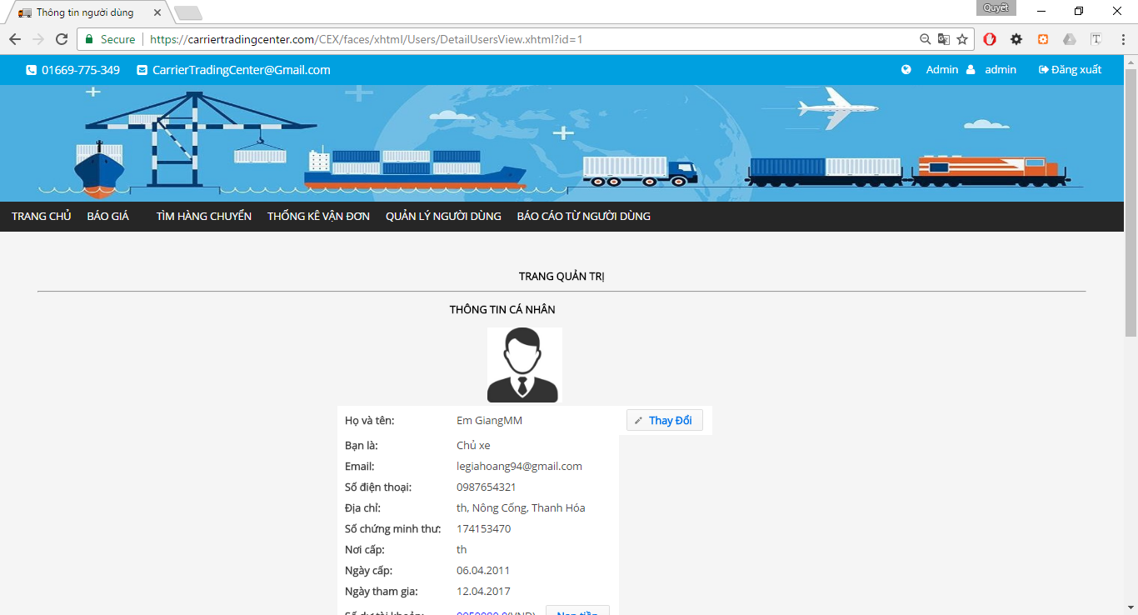

Figure 36 User Profile (part 1)

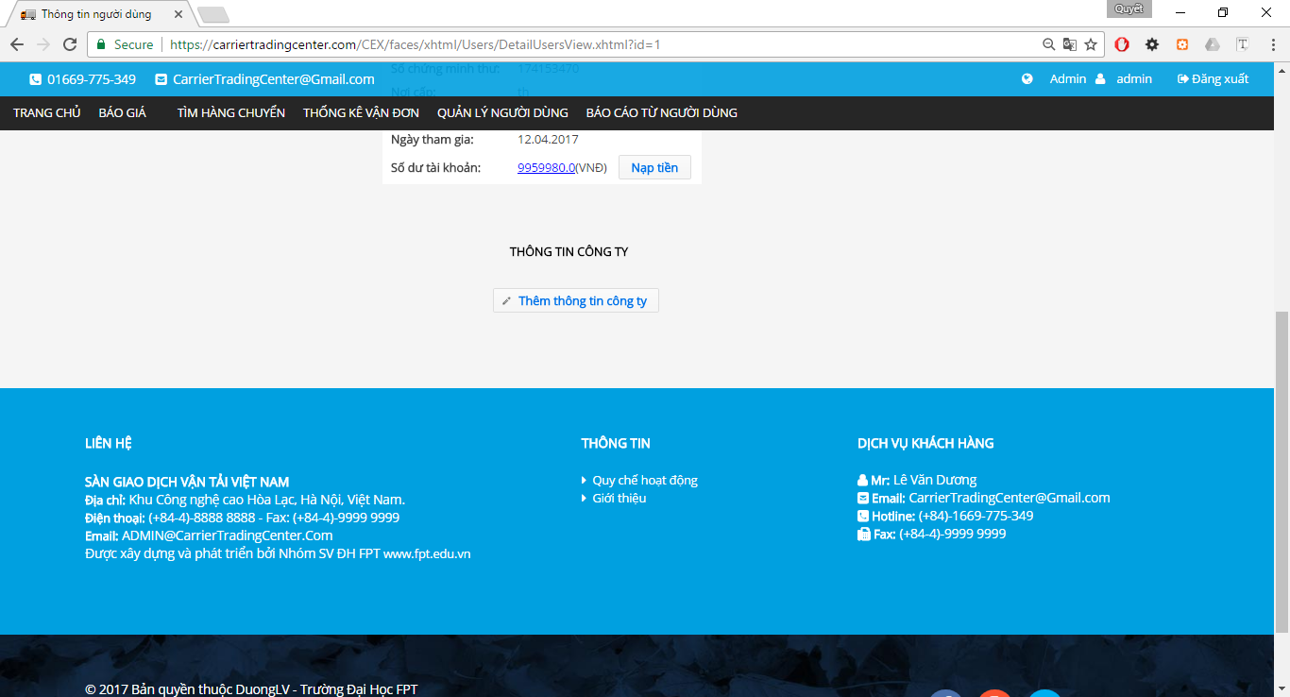

Figure 37 User Profile (part 2)

**Table 2-15** User profile

|  |  |  |  |  |  |  |
| --- | --- | --- | --- | --- | --- | --- |
| **No** | **Object/Control Name** | **Object/Control Name in English** | **Type** | **Required** | **Length** | **Description** |
| 1. 11 | Thông tin cá nhân | userDeatilInformation | panelGrid | Yes |  |  |
| 2 | Thông tin công ty | companyInformation | panelGrid | No |  |  |
|  | Thay đổi |  | commandButton |  |  |  |
|  | Thêm thông tin công ty. |  | commandButton |  |  |  |

#### Case Exist Company Information



Figure 38 User Profile (part 1)



Figure 39 User Profile (part 2)

**Table 2-15** User profile

|  |  |  |  |  |  |  |
| --- | --- | --- | --- | --- | --- | --- |
| **No** | **Object/Control Name** | **Object/Control Name in English** | **Type** | **Required** | **Length** | **Description** |
| 1. 11 | Thông tin cá nhân | userDeatilInformation | panelGrid | Yes |  |  |
| 2 | Thông tin công ty | companyInformation | panelGrid | No |  |  |
|  | Thay đổi |  | commandButton |  |  |  |
|  | Thay đổi |  | commandButton |  |  |  |

### Sequence Diagram



Figure 40 User Profile Sequence Diagram

## Admin activate user

### Class Diagram

### Class Description

### Screen Design

### Sequence Diagram

## Admin deactivate user

### Class Diagram

### Class Description

### Screen Design

### Sequence Diagram

## Admin view operation fee list

### Class Diagram



Figure 41 Price List Class Diagram

### Class Description

#### OperationFeeBean

|  |  |  |  |  |
| --- | --- | --- | --- | --- |
| Class | OperationFeeBean | | | |
| **Description** | Show Operation fee. | | | |
| **Base Class** | BaseBean | | | |
| **Constructor** | N/A | | | |
| **Prototype** | N/A | | | |
| **Source File** | OperationFeeBean.java | | | |
| **Namespace** | vn.co.cex.bean.operationfee | | | |
| **Attributes** | Name | Type | Description | |
| operationFees | List<OpẻationFee> |  | |
| status | Integer |  | |
| **Methods** | Name | Input | Output | Description |
| getOperationFeeBO() |  | OperationFeeBO |  |
| setOperationFeeBO(OperationFeeBO) |  |  |  |
| getOperationFees() |  | List<OperationFee> |  |
| setOperationFees(List<OperationFee>) |  |  |  |
| getStatus() |  | Integer |  |
| setStatus(Integer) |  |  |  |
| searchOperationFee() |  |  |  |

### Screen Design



Figure 42 Price List

**Table 2-18** List Operation Fee

|  |  |  |  |  |  |  |
| --- | --- | --- | --- | --- | --- | --- |
| **No** | **Object/Control Name** | **Object/Control Name in English** | **Type** | **Required** | **Length** | **Description** |
|  | Search condition |  | selectOneMenu |  |  |  |
|  | Tìm kiếm | search | commandButton |  |  |  |
| 1. 11 | Danh sách các loaị chi phí | feeDataTable | dataTable |  |  |  |

### Sequence Diagram



Figure 43 Price List Sequence Diagram

## Admin edit operation fee

### Class Diagram



Figure 44 Edit Operation Fee Class Diagram

### Class Description

#### OperationFeeBean

|  |  |  |  |  |
| --- | --- | --- | --- | --- |
| Class | OperationFeeBean | | | |
| **Description** | Show Operation fee. | | | |
| **Base Class** | BaseBean | | | |
| **Constructor** | N/A | | | |
| **Prototype** | N/A | | | |
| **Source File** | OperationFeeBean.java | | | |
| **Namespace** | vn.co.cex.bean.operationfee | | | |
| **Attributes** | Name | Type | Description | |
| operationFees | List<OpẻationFee> |  | |
| status | Integer |  | |
| **Methods** | Name | Input | Output | Description |
| getOperationFeeBO() |  | OperationFeeBO |  |
| setOperationFeeBO(OperationFeeBO) |  |  |  |
| getOperationFees() |  | List<OperationFee> |  |
| setOperationFees(List<OperationFee>) |  |  |  |
| getStatus() |  | Integer |  |
| setStatus(Integer) |  |  |  |
| searchOperationFee() |  |  |  |

### Screen Design



Figure 45 Edit Operation Fee

**Table 2-19** Edit Operation Fee

|  |  |  |  |  |  |  |
| --- | --- | --- | --- | --- | --- | --- |
| **No** | **Object/Control Name** | **Object/Control Name in English** | **Type** | **Required** | **Length** | **Description** |
|  | Bảng thôn tin chi phí |  | panelGrid |  |  |  |
|  | Tên chi phí | feeNameInput | inputText |  |  |  |
|  | Mã chi phí | operationFeeCode | inputText |  |  |  |
|  | Loại | type | selectOneRadio |  |  |  |
|  | Chi phí | fee | inputNumber |  |  |  |
|  | Tỉ lệ chi phí | feePercent | inputNumber |  |  |  |
|  | Mô tả | descriptioin | inputTextarea |  |  |  |
|  | Xác nhận | confirm | commandButton |  |  |  |
| 1. 11 | Hủy bỏ | cancel | commandButton |  |  |  |

### Sequence Diagram



Figure 46 Edit Operation Fee Sequence Diagram

## Admin reference operation fee

### Class Diagram

### Class Description

### Screen Design

### Sequence Diagram

## Admin add new operation fee

### Class Diagram



Figure 47 Add Operation Fee Class Diagram

### Class Description

#### OperationFeeAddBean

|  |  |  |  |  |
| --- | --- | --- | --- | --- |
| Class | OperationFeeAddBean | | | |
| **Description** | Add Operation fee. | | | |
| **Base Class** | BaseBean | | | |
| **Constructor** | N/A | | | |
| **Prototype** | N/A | | | |
| **Source File** | OperationFeeAddBean.java | | | |
| **Namespace** | vn.co.cex.bean.operationfee | | | |
| **Methods** | Name | Input | Output | Description |
| addNewFee() |  |  |  |

### Screen Design



Figure 48 Add New Operation Fee

**Table 2-19** Add Operation Fee

|  |  |  |  |  |  |  |
| --- | --- | --- | --- | --- | --- | --- |
| **No** | **Object/Control Name** | **Object/Control Name in English** | **Type** | **Required** | **Length** | **Description** |
|  | Bảng thôn tin chi phí |  | panelGrid |  |  |  |
|  | Tên chi phí | feeNameInput | inputText |  |  |  |
|  | Mã chi phí | operationFeeCode | inputText |  |  |  |
|  | Loại | type | selectOneRadio |  |  |  |
|  | Chi phí | fee | inputNumber |  |  |  |
|  | Tỉ lệ chi phí | feePercent | inputNumber |  |  |  |
|  | Mô tả | descriptioin | inputTextarea |  |  |  |
|  | Thêm mới | confirm | commandButton |  |  |  |
| 1. 11 | Hủy bỏ | cancel | commandButton |  |  |  |

### Sequence Diagram



Figure 49 Add New Operation Fee Sequence Diagram

## Admin search report

### Class Diagram



Figure 50 Search Report Class Diagram

### Class Description

#### ReportBean

|  |  |  |  |  |
| --- | --- | --- | --- | --- |
| Class | ReportBean | | | |
| **Description** | Show Operation fee. | | | |
| **Base Class** | BaseBean | | | |
| **Constructor** | N/A | | | |
| **Prototype** | N/A | | | |
| **Source File** | ReportBean.java | | | |
| **Namespace** | vn.co.cex.bean.report | | | |
| **Attributes** | Name | Type | Description | |
| userName | String |  | |
| fullName | String |  | |
| reportTitle | String |  | |
| reportContent | String |  | |
| reportReply | String |  | |
| status | boolean |  | |
| **Methods** | Name | Input | Output | Description |
| searchReportForAdmin() |  |  |  |

### Screen Design



Figure 51 Search Report

**Table 2-22** Search report

|  |  |  |  |  |  |  |
| --- | --- | --- | --- | --- | --- | --- |
| **No** | **Object/Control Name** | **Object/Control Name in English** | **Type** | **Required** | **Length** | **Description** |
|  | Hỗ trợ tìm kiếm |  | panelGrid |  |  |  |
|  | Tên tài khoản |  | inputText |  |  |  |
|  | Tiêu đề báo cáo |  | inputText |  |  |  |
|  | Từ ngày |  | calendar |  |  |  |
|  | Đén ngày |  | calendar |  |  |  |
|  | Danh sách bảo cáo |  | dataTable |  |  |  |

### Sequence Diagram



Figure 52 Search Report Sequence Diagram

## Admin view list report

### Class Diagram



Figure 53 List Report Class Diagram

### Class Description

#### ReportBean

|  |  |  |  |  |
| --- | --- | --- | --- | --- |
| Class | ReportBean | | | |
| **Description** | Show Operation fee. | | | |
| **Base Class** | BaseBean | | | |
| **Constructor** | N/A | | | |
| **Prototype** | N/A | | | |
| **Source File** | ReportBean.java | | | |
| **Namespace** | vn.co.cex.bean.report | | | |
| **Attributes** | Name | Type | Description | |
| userName | String |  | |
| fullName | String |  | |
| reportTitle | String |  | |
| reportContent | String |  | |
| reportReply | String |  | |
| status | boolean |  | |
| **Methods** | Name | Input | Output | Description |
| searchReportForAdmin() |  |  |  |

### Screen Design



Figure 54 List Report

**Table 2-23** Search report

|  |  |  |  |  |  |  |
| --- | --- | --- | --- | --- | --- | --- |
| **No** | **Object/Control Name** | **Object/Control Name in English** | **Type** | **Required** | **Length** | **Description** |
|  | Hỗ trợ tìm kiếm |  | panelGrid |  |  |  |
|  | Tên tài khoản |  | inputText |  |  |  |
|  | Tiêu đề báo cáo |  | inputText |  |  |  |
|  | Từ ngày |  | calendar |  |  |  |
|  | Đén ngày |  | calendar |  |  |  |
|  | Danh sách bảo cáo |  | dataTable |  |  |  |

### Sequence Diagram



Figure 55 List Report Sequence Diagram

## Admin response report

### Class Diagram



Figure 56 Response report

### Class Description

#### ReportDetailBean

|  |  |  |  |  |
| --- | --- | --- | --- | --- |
| Class | ReportDetailBean | | | |
| **Description** | Show detail report and response. | | | |
| **Base Class** | BaseBean | | | |
| **Constructor** | N/A | | | |
| **Prototype** | N/A | | | |
| **Source File** | ReportDetailBean.java | | | |
| **Namespace** | vn.co.cex.bean.report | | | |
| **Attributes** | Name | Type | Description | |
| isSuccess | boolean |  | |
| id | int |  | |
| userID | int |  | |
| reportTitle | String |  | |
| reportQuestion | String |  | |
| reportSolution | String |  | |
| reportContent | String |  | |
| reportReply | String |  | |
| status | boolean |  | |
| **Methods** | Name | Input | Output | Description |
| updateReportReply() |  |  |  |
| goToListReportUser() |  |  |  |

### Screen Design



Figure 57 Response Report

**Table 2-24** Search report

|  |  |  |  |  |  |  |
| --- | --- | --- | --- | --- | --- | --- |
| **No** | **Object/Control Name** | **Object/Control Name in English** | **Type** | **Required** | **Length** | **Description** |
|  | Báo cáo chi tiết | reportDetail | panelGrid |  |  |  |
|  | Tiêu đề báo cáo | fullName | outputText |  |  |  |
|  | Người gửi | userName | outputText |  |  |  |
|  | Tài khoản người gửi | userName | outputText |  |  |  |
|  | Người nhận |  | outputText |  |  |  |
|  | Ngày gửi | reportDate | outputLable |  |  |  |
|  | Câu hoi từ người dung | reportQuestion | outputLable |  |  |  |
|  | Mong muốn xử lý | reportSolution | outputLable |  |  |  |
|  | Nội dung | reportContent | outputLable |  |  |  |
|  | Phản hồi | reportReply | inputTextarea |  |  |  |
|  | Phản hồi | submit | commandButton |  |  |  |
|  | Quay lại | goback | commandButton |  |  |  |

### Sequence Diagram



Figure 58 Response Report Sequence Diagram

## Admin edit user profile

### Class Diagram



Figure 59 Edit User Profile Class Diagram

### Class Description

#### UsersDetailBean

|  |  |  |  |
| --- | --- | --- | --- |
| Class | UsersDetailBean | | |
| **Description** | Show bill of lading and search bill of lading. | | |
| **Base Class** | BaseBean | | |
| **Constructor** | N/A | | |
| **Prototype** | N/A | | |
| **Source File** | UsersDetailBean.java | | |
| **Namespace** | vn.co.cex.bean.users | | |
| **Attributes** | Name | Type | Description |
| name | String |  |
| taxCode | String |  |
| email | String |  |
| phoneNumber | String |  |
| fax | String |  |
| filename | String |  |
| districtName | String |  |
| provinceName | String |  |
| address | String |  |
| issuccess | bolean |  |
| amount | Float |  |

### Screen Design

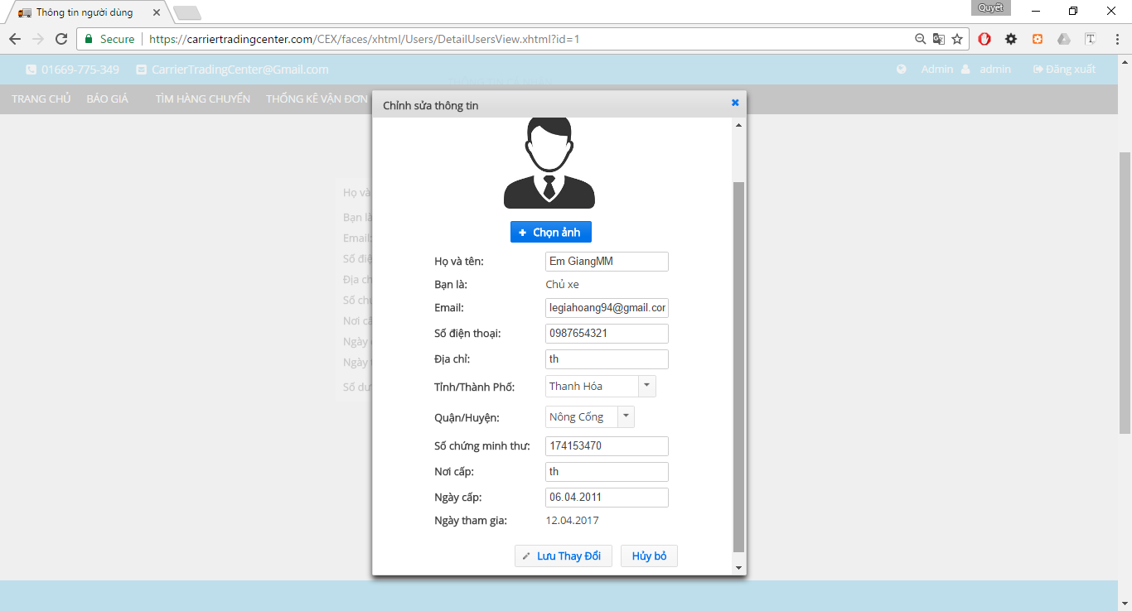

Figure 60 Edit User Profile

**Table 2-25** Edit user profile

|  |  |  |  |  |  |  |
| --- | --- | --- | --- | --- | --- | --- |
| **No** | **Object/Control Name** | **Object/Control Name in English** | **Type** | **Required** | **Length** | **Description** |
|  | avatar | avatar | graphicImage |  |  |  |
|  | Chọn ảnh | chooseImg | fileUpload |  |  |  |
|  | Họ và tên | fullName | inputText |  |  |  |
|  | Bạn là | role | outputlable |  |  |  |
|  | Email | email | inputText |  |  |  |
|  | Số điện thoại | phoneNumber | inputText |  |  |  |
|  | Địa chỉ | address | inputText |  |  |  |
|  | Tỉnh/Thành phố | province | selectOneMenu |  |  |  |
|  | Quận/Huyện | district | selectOneMenu |  |  |  |
|  | Số chứng minh thư | identityCard | inputText |  |  |  |
|  | Nơi cấp | identityCardPlace | inputText |  |  |  |
|  | Ngày cấp | identityCardDate | inputText |  |  |  |
|  | Ngày tham gia | dateCreate | outputlable |  |  |  |
|  | Lưu thay đổi | save | commandButton |  |  |  |
|  | Hủy bỏ | cancel | commandButton |  |  |  |

### Sequence Diagram



Figure 61 Edit User Profile Sequence Diagram

## Admin change password

### Class Diagram

### Class Description

### Screen Design

### Sequence Diagram

## Admin forgot password

### Class Diagram



Figure 62 Forgot Password Class Diagram

### Class Description

#### ForgotPasswordBean

|  |  |  |  |  |
| --- | --- | --- | --- | --- |
| Class | ForgotPasswordBean | | | |
| **Description** | Support user change password when forgot. | | | |
| **Base Class** | BaseBean | | | |
| **Constructor** | N/A | | | |
| **Prototype** | N/A | | | |
| **Source File** | ForgotPasswordBean.java | | | |
| **Namespace** | vn.co.cex.bean.login | | | |
| **Attributes** | Name | Type | Description | |
| email | String |  | |
| password | String |  | |
| state | int |  | |
| oldPassword | String |  | |
| passwordGenerated | String |  | |
| **Methods** | Name | Input | Output | Description |
| resetPassword () |  |  |  |
| sendMailResetPassword() |  |  |  |
| encryptPassword() |  |  |  |

### Screen Design



Figure 63 Forgot Password

**Table 2-27.1 Send mail forgot password**

|  |  |  |  |  |  |  |
| --- | --- | --- | --- | --- | --- | --- |
| **No** | **Object/Control Name** | **Object/Control Name in English** | **Type** | **Required** | **Length** | **Description** |
|  | Quên mật khẩu | forgotPassword | panelGrid |  |  |  |
|  | Email đã đăng ký | email | inputText |  |  |  |
|  | Gửi | send | commandButton |  |  |  |



Figure 64 Reset Password

**Table 2-27.2** Reset passwords

|  |  |  |  |  |  |  |
| --- | --- | --- | --- | --- | --- | --- |
| **No** | **Object/Control Name** | **Object/Control Name in English** | **Type** | **Required** | **Length** | **Description** |
|  | Thay đổi mật khẩu | resetPassword | panelGrid |  |  |  |
|  | Địa chỉ email | chooseImg | inputText |  |  |  |
|  | Mật khẩu cũ | fullName | password |  |  |  |
|  | Mật khẩu mới | role | password |  |  |  |
|  | Xác nhận mật khẩu | email | password |  |  |  |
|  | Đổi mật khẩu | phoneNumber | commandButton |  |  |  |

### Sequence Diagram



Figure 65 Forgot Password Sequence Diagram

## Admin login

### Class Diagram



Figure 66 Login Class Diagram

### Class Description

#### LoginBean

|  |  |  |  |  |
| --- | --- | --- | --- | --- |
| Class | LoginBean | | | |
| **Description** | Login to the system. | | | |
| **Base Class** | BaseBean | | | |
| **Constructor** | N/A | | | |
| **Prototype** | N/A | | | |
| **Source File** | LoginBean.java | | | |
| **Namespace** | vn.co.cex.bean.login | | | |
| **Attributes** | Name | Type | Description | |
| email | String |  | |
| password | String |  | |
| role | int |  | |
| fullName | String |  | |
| status | int |  | |
| **Methods** | Name | Input | Output | Description |
| checkLogin () |  |  |  |

### Screen Design



Figure 67 Login

**Table 2-28** Reset passwords

|  |  |  |  |  |  |  |
| --- | --- | --- | --- | --- | --- | --- |
| **No** | **Object/Control Name** | **Object/Control Name in English** | **Type** | **Required** | **Length** | **Description** |
|  | Đăng nhập | loginForm | panelGrid |  |  |  |
|  | Email | email | inputText |  |  |  |
|  | Mật khẩu | password | password |  |  |  |

### Sequence Diagram



Figure 68 Login Sequence Diagram

## Admin logout

### Class Diagram



Figure 69 Logout Class Diagram

### Class Description

#### LoginBean

|  |  |  |  |  |
| --- | --- | --- | --- | --- |
| Class | LoginBean | | | |
| **Description** | Login to the system. | | | |
| **Base Class** | BaseBean | | | |
| **Constructor** | N/A | | | |
| **Prototype** | N/A | | | |
| **Source File** | LoginBean.java | | | |
| **Namespace** | vn.co.cex.bean.login | | | |
| **Attributes** | Name | Type | Description | |
| email | String |  | |
| password | String |  | |
| role | int |  | |
| fullName | String |  | |
| status | int |  | |
| **Methods** | Name | Input | Output | Description |
| checkLogin () |  |  |  |

### Screen Design



Figure 70 Logout

**Table 2-29** Logout

|  |  |  |  |  |  |  |
| --- | --- | --- | --- | --- | --- | --- |
| **No** | **Object/Control Name** | **Object/Control Name in English** | **Type** | **Required** | **Length** | **Description** |
|  | Đăng xuất | logout | commandLink |  |  |  |

### Sequence Diagram



Figure 71 Logout Sequence Diagram

## Admin view transaction history

### Class Diagram

### Class Description

### Screen Design

### Sequence Diagram

## Admin view price table history

### Class Diagram



Figure 72 View Price Table History Class Diagram

### Class Description

#### OperationFeeBean

|  |  |  |  |  |
| --- | --- | --- | --- | --- |
| Class | OperationFeeBean | | | |
| **Description** | Show Operation fee. | | | |
| **Base Class** | BaseBean | | | |
| **Constructor** | N/A | | | |
| **Prototype** | N/A | | | |
| **Source File** | OperationFeeBean.java | | | |
| **Namespace** | vn.co.cex.bean.operationfee | | | |
| **Attributes** | Name | Type | Description | |
| operationFees | List<OpẻationFee> |  | |
| status | Integer |  | |
| **Methods** | Name | Input | Output | Description |
| getOperationFeeBO() |  | OperationFeeBO |  |
| setOperationFeeBO(OperationFeeBO) |  |  |  |
| getOperationFees() |  | List<OperationFee> |  |
| setOperationFees(List<OperationFee>) |  |  |  |
| getStatus() |  | Integer |  |
| setStatus(Integer) |  |  |  |
| searchOperationFee() |  |  |  |

### Screen Design



Figure 73 History Price

**Table 2-31** History Operation Fee

|  |  |  |  |  |  |  |
| --- | --- | --- | --- | --- | --- | --- |
| **No** | **Object/Control Name** | **Object/Control Name in English** | **Type** | **Required** | **Length** | **Description** |
|  | Search condition |  | selectOneMenu |  |  |  |
|  | Tìm kiếm | search | commandButton |  |  |  |
| 1. 11 | Danh sách các loaị chi phí | feeDataTable | dataTable |  |  |  |

### Sequence Diagram



Figure 74 History price Sequence Diagram

## Admin recharge for user

### Class Diagram



Figure 75 Account Recharge Class Diagram

### Class Description

#### UserDetailBean

|  |  |  |  |  |
| --- | --- | --- | --- | --- |
| Class | OperationFeeBean | | | |
| **Description** | Show bill of lading and search bill of lading. | | | |
| **Base Class** | BaseBean | | | |
| **Constructor** | N/A | | | |
| **Prototype** | N/A | | | |
| **Source File** | UsersDetailBean.java | | | |
| **Namespace** | vn.co.cex.bean.users | | | |
| **Attributes** | Name | Name | Name | |
| name | String | name | |
| taxCode | String | taxCode | |
| email | String | email | |
| phoneNumber | String | phoneNumber | |
| fax | String | fax | |
| filename | String | filename | |
| districtName | String | districtName | |
| provinceName | String | provinceName | |
| address | String | address | |
| issuccess | bolean | issuccess | |
| amount | Float | amount | |
| **Methods** | Name | Input | Output | Description |
| rechargeUserAccount() |  |  |  |

### Screen Design

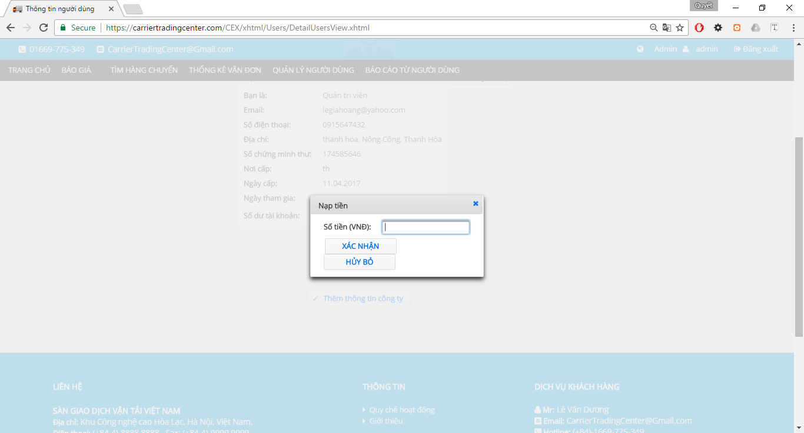

Figure 76 Recharger Account

**Table 2-32** Recharge account

|  |  |  |  |  |  |  |
| --- | --- | --- | --- | --- | --- | --- |
| **No** | **Object/Control Name** | **Object/Control Name in English** | **Type** | **Required** | **Length** | **Description** |
|  | Số tiền(VND) | amount | inputText |  |  |  |
|  | Xác nhận | confirm | commandButton |  |  |  |
| 1. 11 | Hủy bỏ | cancel | commandButton |  |  |  |

### Sequence Diagram



Figure 77 Recharge Account Sequence Diagram

## Admin add company information

### Class Diagram



### Class Description

#### UserDetailBean

|  |  |  |  |  |
| --- | --- | --- | --- | --- |
| Class | OperationFeeBean | | | |
| **Description** | Show bill of lading and search bill of lading. | | | |
| **Base Class** | BaseBean | | | |
| **Constructor** | N/A | | | |
| **Prototype** | N/A | | | |
| **Source File** | UsersDetailBean.java | | | |
| **Namespace** | vn.co.cex.bean.users | | | |
| **Attributes** | Name | Name | Name | |
| name | String | name | |
| taxCode | String | taxCode | |
| email | String | email | |
| phoneNumber | String | phoneNumber | |
| fax | String | fax | |
| filename | String | filename | |
| districtName | String | districtName | |
| provinceName | String | provinceName | |
| address | String | address | |
| issuccess | bolean | issuccess | |
| amount | Float | amount | |
| **Methods** | Name | Input | Output | Description |
| addCompany() |  |  |  |

### Screen Design

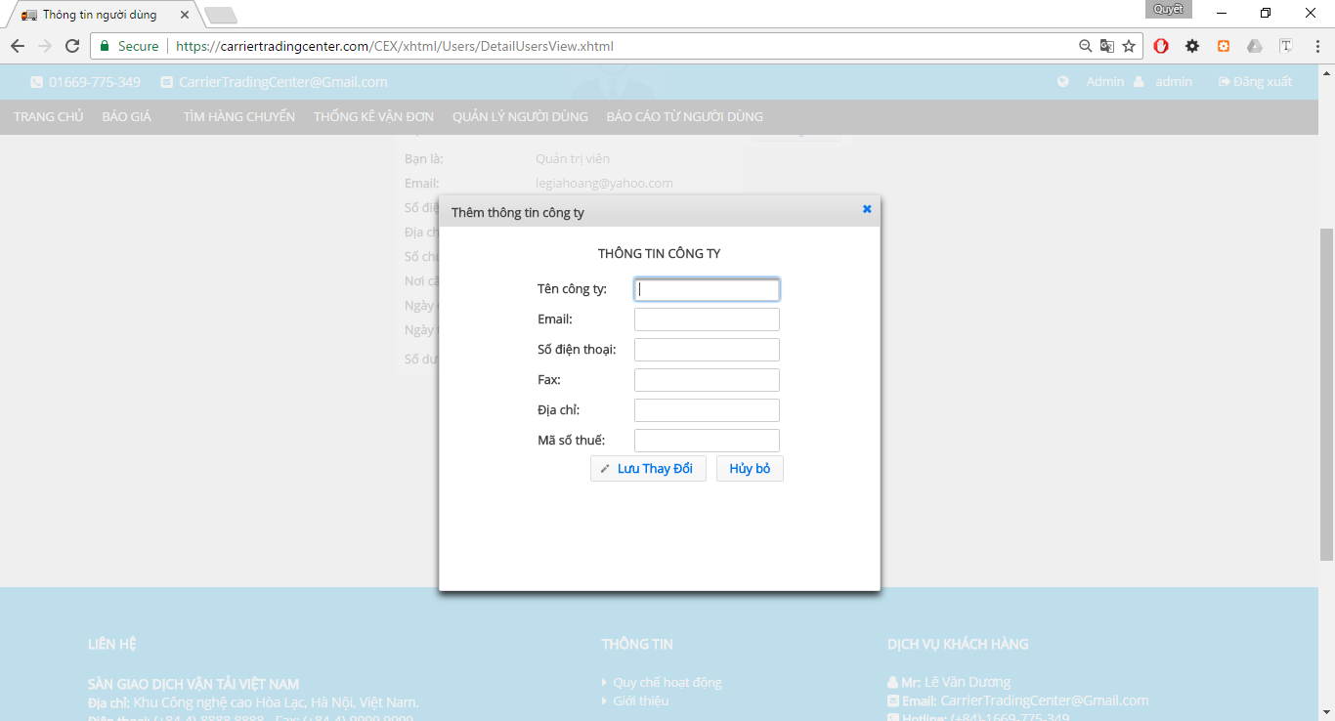

Figure 78 Add Company

**Table 2-33** Add Company

|  |  |  |  |  |  |  |
| --- | --- | --- | --- | --- | --- | --- |
| **No** | **Object/Control Name** | **Object/Control Name in English** | **Type** | **Required** | **Length** | **Description** |
|  | Thông tin công ty | companyInformation | panelGrid |  |  |  |
|  | Tên công ty | comapnyName | inputText |  | 100 |  |
|  | Email | email | inputText |  | 50 |  |
|  | Số điện thoại | phoneNumber | inputText |  | 11 |  |
|  | Fax | fax | inputText |  | 20 |  |
|  | Địa chỉ | address | inputText |  | 100 |  |
| 1. 11 | Mã số thuế | taxCode | inputText |  | 20 |  |
|  | Lưu thay đổi | confirm | commandButton |  |  |  |
|  | Hủy bỏ | cancel | commandButton |  |  |  |

### Sequence Diagram

## Admin edit company information

### Class Diagram



Figure 79 Edit Company Information’s Class Diagram

### Class Description

#### UserDetailBean

|  |  |  |  |  |
| --- | --- | --- | --- | --- |
| Class | OperationFeeBean | | | |
| **Description** | Show bill of lading and search bill of lading. | | | |
| **Base Class** | BaseBean | | | |
| **Constructor** | N/A | | | |
| **Prototype** | N/A | | | |
| **Source File** | UsersDetailBean.java | | | |
| **Namespace** | vn.co.cex.bean.users | | | |
| **Attributes** | Name | Name | Name | |
| name | String | name | |
| taxCode | String | taxCode | |
| email | String | email | |
| phoneNumber | String | phoneNumber | |
| fax | String | fax | |
| filename | String | filename | |
| districtName | String | districtName | |
| provinceName | String | provinceName | |
| address | String | address | |
| issuccess | bolean | issuccess | |
| amount | Float | amount | |
| **Methods** | Name | Input | Output | Description |
| updateCompany() |  |  |  |

### Screen Design



Figure 80 Edit Company Information’s

**Table 2-33** Edit Company Information

|  |  |  |  |  |  |  |
| --- | --- | --- | --- | --- | --- | --- |
| **No** | **Object/Control Name** | **Object/Control Name in English** | **Type** | **Required** | **Length** | **Description** |
|  | Thông tin công ty | companyInformation | panelGrid |  |  |  |
|  | Tên công ty | comapnyName | inputText |  | 100 |  |
|  | Email | email | inputText |  | 50 |  |
|  | Số điện thoại | phoneNumber | inputText |  | 11 |  |
|  | Fax | fax | inputText |  | 20 |  |
|  | Địa chỉ | address | inputText |  | 100 |  |
| 1. 11 | Mã số thuế | taxCode | inputText |  | 20 |  |
|  | Lưu thay đổi | confirm | commandButton |  |  |  |
|  | Hủy bỏ | cancel | commandButton |  |  |  |

### Sequence Diagram



Figure 81 Edit Company Information's Sequence Diagram

## Goods owner view list bill of lading

### Class Diagram



Figure 82 Goods Owner View List Bills of Lading

### Class Description

#### CommonBean

|  |  |  |  |  |
| --- | --- | --- | --- | --- |
| Class | CommonBean | | | |
| **Description** | Show bill of lading and search bill of lading. | | | |
| **Base Class** | BaseBean | | | |
| **Constructor** | N/A | | | |
| **Prototype** | N/A | | | |
| **Source File** | CommonBean.java | | | |
| **Namespace** | vn.co.cex.bean.billoflading | | | |
| **Attributes** | Name | Type | Description | |
| goodsTypeId | Integer |  | |
| packagedFormId | Integer |  | |
| weight | Float |  | |
| volume | Float |  | |
| departureProvinceCode | String |  | |
| arrivalProvinceCode | String |  | |
| status | Integer |  | |
| timeRemaining | int |  | |
| **Methods** | Name | Input | Output | Description |
| searchBillOfLading() |  |  |  |

### Screen Design

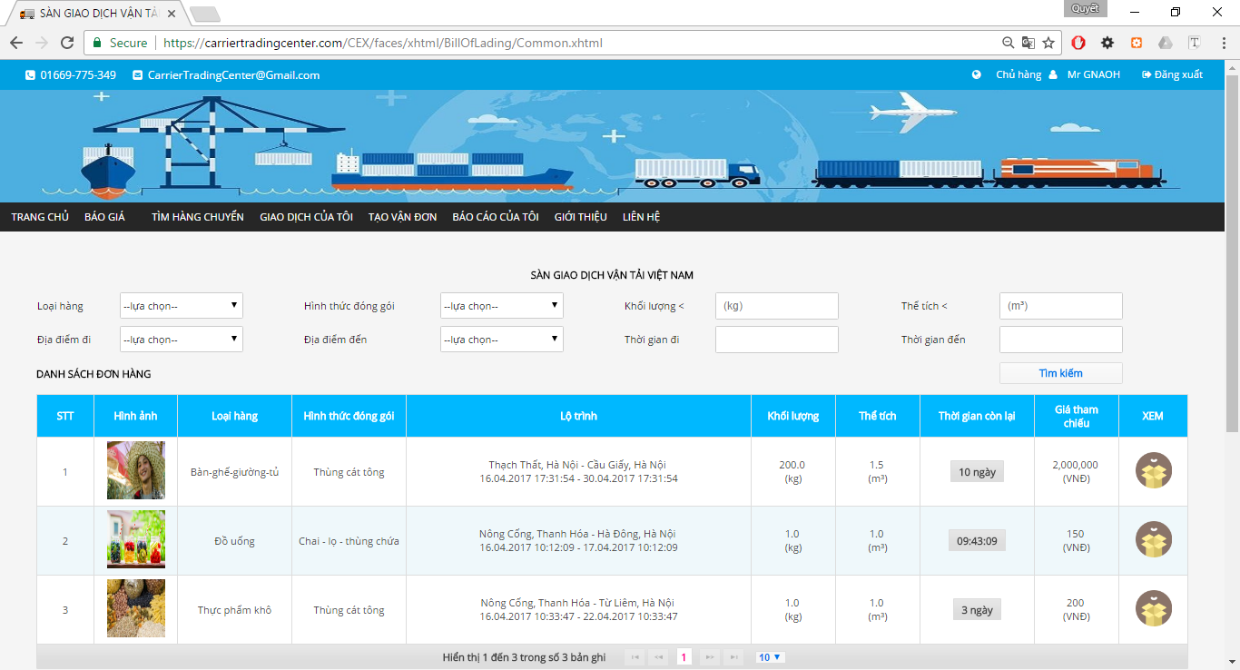

Figure 83 List Bills of Lading

**Table 2-35** Bills of Lading

|  |  |  |  |  |  |  |
| --- | --- | --- | --- | --- | --- | --- |
| **No** | **Object/Control Name** | **Object/Control Name in English** | **Type** | **Required** | **Length** | **Description** |
| 1. 11 | Loại Hàng | goodTypeId | selectOneMenu | No |  |  |
| 2 | Hình thức đóng gói | packageFormId | selectOneMenu | No |  |  |
| 3 | Khối lượng | weight | inputText | No |  |  |
|  | Thể tích | volume | inputText | No |  |  |
|  | Địa điểm đi | slbDepartureProvinceID | selectOneMenu | No |  |  |
|  | Địa điêm đến | slbArrivalProvinceID | selectOneMenu | No |  |  |
|  | Thời gian đi | departureDate | calendar | No |  |  |
|  | Thời gian đến | arrivalDate | calendar | No |  |  |
|  | Tìm kiếm | search | commandButton |  |  |  |
|  | Danh sách đơn hàng | table_billoflading | dataTable |  |  |  |

### Sequence Diagram



Figure 84 List Bill of Lading Sequence Diagram

## Goods owner view detail bill of lading

### Class Diagram



Figure 85 Detail Bills of Lading

### Class Description

#### BillOfLadingDetailBean

|  |  |  |  |  |
| --- | --- | --- | --- | --- |
| Class | BillOfLadingDetailBean | | | |
| **Description** | Show detail bill of lading. | | | |
| **Base Class** | BaseBean | | | |
| **Constructor** | N/A | | | |
| **Prototype** | N/A | | | |
| **Source File** | BillOfLadingDetailBean.java | | | |
| **Namespace** | vn.co.cex.bean.billoflading | | | |
| **Methods** | Name | Input | Output | Description |
|  |  |  |  |

### Screen Design

#### Owned



Figure 86 Detail Bills of Lading (part 1)



Figure 87 Detail Bills of Lading (part 2)

**Table 2-36.1** Detailbills of Lading

|  |  |  |  |  |  |  |
| --- | --- | --- | --- | --- | --- | --- |
| **No** | **Object/Control Name** | **Object/Control Name in English** | **Type** | **Required** | **Length** | **Description** |
| 1. 11 | Thông tin hàng hóa cần vận chuyển | goodInformation | selectOneMenu |  |  |  |
| 2 | Google Map | map | javaScript |  |  |  |
|  | Hủy giao dịch | cancelBillOflading | commandButton |  |  |  |
|  | Hỏi đáp |  | panelGroup |  |  |  |

#### Other



Figure 88 Detail Bills of Lading

**Table 2-35.2** Detailbills of Lading

|  |  |  |  |  |  |  |
| --- | --- | --- | --- | --- | --- | --- |
| **No** | **Object/Control Name** | **Object/Control Name in English** | **Type** | **Required** | **Length** | **Description** |
| 1. 11 | Thông tin hàng hóa cần vận chuyển | goodInformation | selectOneMenu |  |  |  |
| 2 | Google Map | map | javaScript |  |  |  |

### Sequence Diagram



Figure 89 Detail Bills of Lading Sequence Diagram

## Goods owner search bill of lading

### Class Diagram



Figure 90 Search Bill of Lading class Diagram

### Class Description

#### CommonBean

|  |  |  |  |  |
| --- | --- | --- | --- | --- |
| Class | CommonBean | | | |
| **Description** | Show bill of lading and search bill of lading. | | | |
| **Base Class** | BaseBean | | | |
| **Constructor** | N/A | | | |
| **Prototype** | N/A | | | |
| **Source File** | CommonBean.java | | | |
| **Namespace** | vn.co.cex.bean.billoflading | | | |
| **Attributes** | Name | Type | Description | |
| goodsTypeId | Integer |  | |
| packagedFormId | Integer |  | |
| weight | Float |  | |
| volume | Float |  | |
| departureProvinceCode | String |  | |
| arrivalProvinceCode | String |  | |
| status | Integer |  | |
| timeRemaining | int |  | |
| **Methods** | Name | Input | Output | Description |
| searchBillOfLading() |  |  |  |

### Screen Design



Figure 91 Search Bills of Lading

**Table 2-37** Bills of Lading

|  |  |  |  |  |  |  |
| --- | --- | --- | --- | --- | --- | --- |
| **No** | **Object/Control Name** | **Object/Control Name in English** | **Type** | **Required** | **Length** | **Description** |
| 1. 11 | Loại Hàng | goodTypeId | selectOneMenu | No |  |  |
| 2 | Hình thức đóng gói | packageFormId | selectOneMenu | No |  |  |
| 3 | Khối lượng | weight | inputText | No |  |  |
|  | Thể tích | volume | inputText | No |  |  |
|  | Địa điểm đi | slbDepartureProvinceID | selectOneMenu | No |  |  |
|  | Địa điêm đến | slbArrivalProvinceID | selectOneMenu | No |  |  |
|  | Thời gian đi | departureDate | calendar | No |  |  |
|  | Thời gian đến | arrivalDate | calendar | No |  |  |
|  | Tìm kiếm | search | commandButton |  |  |  |
|  | Danh sách đơn hàng | table_billoflading | dataTable |  |  |  |

### Sequence Diagram



Figure 92 Search Bill of Lading Sequence Diagram

## Goods owner view carrier auction success

### Class Diagram

### Class Description

### Screen Design

### Sequence Diagram

## Goods owner view transaction history

### Class Diagram

### Class Description

### Screen Design

### Sequence Diagram

## Goods owner register a new bill of lading

### Class Diagram



Figure 93 Register new Bill of Lading

### Class Description

#### PostBillOfLadingBean

|  |  |  |  |  |
| --- | --- | --- | --- | --- |
| Class | PostBillOfLadingBean | | | |
| **Description** | Show bill of lading and search bill of lading. | | | |
| **Base Class** | BaseBean | | | |
| **Constructor** | N/A | | | |
| **Prototype** | N/A | | | |
| **Source File** | PostBillOfLadingBean.java | | | |
| **Namespace** | vn.co.cex.bean.billoflading | | | |
| **Methods** | Name | Input | Output | Description |
| postBillOfLading() |  |  |  |
| gotoListBillOfLading() |  |  |  |

### Screen Design



Figure 94 Post Bill of Lading (part 1)



Figure 95 Post Bill of Lading (part 2)



Figure 96 Post Bill of Lading (part 3)



Figure 97 Post Bill of Lading (part 4)

**Table 2-40** Postbills of Lading

|  |  |  |  |  |  |  |
| --- | --- | --- | --- | --- | --- | --- |
| **No** | **Object/Control Name** | **Object/Control Name in English** | **Type** | **Required** | **Length** | **Description** |
| 1. 11 | Mã vận đơn | Code | inputText | No | 20 |  |
| 2 | Loại hàng | goodsType | selectOneMenu | Yes |  |  |
| 3 | Hình thức đóng gói. | packageForm | selectOneMenu | Yes |  |  |
|  | Họ và tên người gửi | sender | inputText | Yes | 50 |  |
|  | Số điện thoại | sender PhoneNumber | inputText | Yes | 12 |  |
|  | Họ và tên người nhận | receiver | inputText | Yes | 50 |  |
|  | Số điện thoại | receiverPhoneNumber | inputText | Yes | 12 |  |
|  | Địa điêm gửi | departureProvince | selectOneMenu | Yes |  |  |
|  | Địa điểm nhận | arrivalProvince | selectOneMenu | Yes |  |  |
|  | Đi từ quận/huyện | departureDistrict | selectOneMenu | Yes |  |  |
|  | Đến quận/huyện | arrivalDistrict | selectOneMenu | Yes |  |  |
|  | Địa chỉ nơi gửi | departureAddress | inputText | Yes | 100 |  |
|  | Địa chỉ nơi nhận | arrivalAddress | inputText | Yes | 100 |  |
|  | Đặc điểm nơi gửi | departureCharacteristicPlace | inputText | No | 100 |  |
|  | Đặc điểm nơi nhận | arrivalCharacteristicPlace | inputText | No | 100 |  |
|  | Ngày gửi | departureDate | calendar | Yes |  |  |
|  | Ngày nhận | arrivalDate | calendar | Yes |  |  |
|  | Quãng đường | distance | inputNumber | Yes |  |  |
|  | Khối lượng | weight | inputNumber | Yes |  |  |
|  | Số lượng | quantity | inputNumber | No |  |  |
|  | Dài | lenght | inputNumber | Yes |  |  |
|  | Rộng | width | inputNumber | Yes |  |  |
|  | Cao | height | inputNumber | Yes |  |  |
|  | Hàng đông lạnh | isFrozen | selectBooleanCheckbox | No |  |  |
|  | Hàng dễ vỡ | isFragile | selectBooleanCheckbox | No |  |  |
|  | Hình ảnh | goodsImage | fileUpload | No | 255 |  |
|  | Mô tả | description | inputTextarea | No | 200 |  |
|  | Giá đề xuất | price | inputNumber | Yes |  |  |
|  | Thời gian kết thúc đấu giá | currentDate | calendar | Yes |  |  |
|  | Đăng ký |  | commandButton |  |  |  |
|  | Hủy bỏ |  | commandButton |  |  |  |

### Sequence Diagram



Figure 98 Post Bill of Lading Sequence Diagram

## Goods owner cancel bill of Lading

### Class Diagram



Figure 99 Cancel Bill of Lading Class Diagram

### Class Description

#### BillOfLadingDetailBean

|  |  |  |  |  |
| --- | --- | --- | --- | --- |
| Class | BillOfLadingDetailBean | | | |
| **Description** | Show detail bill of lading. | | | |
| **Base Class** | BaseBean | | | |
| **Constructor** | N/A | | | |
| **Prototype** | N/A | | | |
| **Source File** | BillOfLadingDetailBean.java | | | |
| **Namespace** | vn.co.cex.bean.billoflading | | | |
| **Methods** | Name | Input | Output | Description |
| goodsOwnerCancelAuction() |  |  |  |

### Screen Design



Figure 100 Cancel Bill of Lading

**Table 2-37** Cancelbills of Lading

|  |  |  |  |  |  |  |
| --- | --- | --- | --- | --- | --- | --- |
| **No** | **Object/Control Name** | **Object/Control Name in English** | **Type** | **Required** | **Length** | **Description** |
| 1. 11 | Thông tin hàng hóa cần vận chuyển | goodInformation | selectOneMenu |  |  |  |
| 2 | Google Map | map | javaScript |  |  |  |
|  | Hủy giao dịch | cancelBillOflading | commandButton |  |  |  |
|  | Hỏi đáp |  | panelGroup |  |  |  |

### Sequence Diagram



Figure 101 Cancel Bill of Lading Sequence Diagram

## Goods owner edit profile

### Class Diagram



Figure 102 Edit Profile Class Diagram

### Class Description

#### UsersDetailBean

|  |  |  |  |
| --- | --- | --- | --- |
| Class | UsersDetailBean | | |
| **Description** | Show bill of lading and search bill of lading. | | |
| **Base Class** | BaseBean | | |
| **Constructor** | N/A | | |
| **Prototype** | N/A | | |
| **Source File** | UsersDetailBean.java | | |
| **Namespace** | vn.co.cex.bean.users | | |
| **Attributes** | Name | Type | Description |
| name | String |  |
| taxCode | String |  |
| email | String |  |
| phoneNumber | String |  |
| fax | String |  |
| filename | String |  |
| districtName | String |  |
| provinceName | String |  |
| address | String |  |
| issuccess | bolean |  |
| amount | Float |  |

### Screen Design

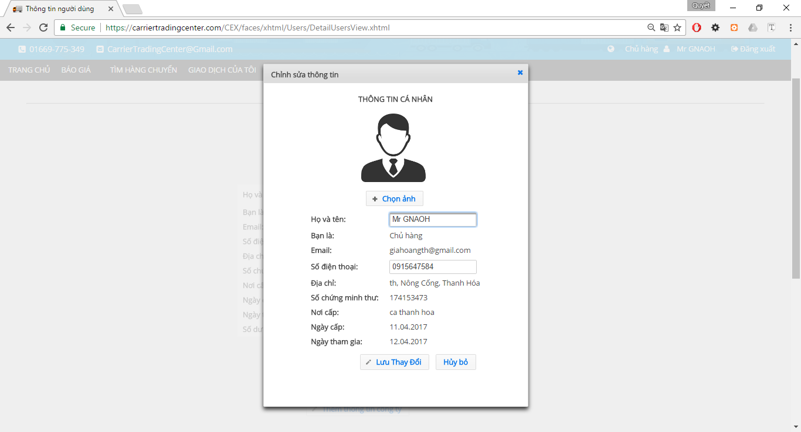

Figure 103 Edit profile

**Table 2-25** Edit profile

|  |  |  |  |  |  |  |
| --- | --- | --- | --- | --- | --- | --- |
| **No** | **Object/Control Name** | **Object/Control Name in English** | **Type** | **Required** | **Length** | **Description** |
|  | avatar | avatar | graphicImage |  |  |  |
|  | Chọn ảnh | chooseImg | fileUpload |  |  |  |
|  | Họ và tên | fullName | inputText |  |  |  |
|  | Bạn là | role | outputlable |  |  |  |
|  | Email | email | outputlable |  |  |  |
|  | Số điện thoại | phoneNumber | inputText |  |  |  |
|  | Địa chỉ | address | outputlable |  |  |  |
|  | Tỉnh/Thành phố | province | outputlable |  |  |  |
|  | Quận/Huyện | district | outputlable |  |  |  |
|  | Số chứng minh thư | identityCard | outputlable |  |  |  |
|  | Nơi cấp | identityCardPlace | outputlable |  |  |  |
|  | Ngày cấp | identityCardDate | outputlable |  |  |  |
|  | Ngày tham gia | dateCreate | outputlable |  |  |  |
|  | Lưu thay đổi | save | commandButton |  |  |  |
|  | Hủy bỏ | cancel | commandButton |  |  |  |

### Sequence Diagram



Figure 104 Edit Profile Sequence Diagram

## Goods owner forgot password

### Class Diagram



Figure 105 Forgot Password Class Diagram

### Class Description

#### ForgotPasswordBean

|  |  |  |  |  |
| --- | --- | --- | --- | --- |
| Class | ForgotPasswordBean | | | |
| **Description** | Support user change password when forgot. | | | |
| **Base Class** | BaseBean | | | |
| **Constructor** | N/A | | | |
| **Prototype** | N/A | | | |
| **Source File** | ForgotPasswordBean.java | | | |
| **Namespace** | vn.co.cex.bean.login | | | |
| **Attributes** | Name | Type | Description | |
| email | String |  | |
| password | String |  | |
| state | int |  | |
| oldPassword | String |  | |
| passwordGenerated | String |  | |
| **Methods** | Name | Input | Output | Description |
| resetPassword () |  |  |  |
| sendMailResetPassword() |  |  |  |
| encryptPassword() |  |  |  |

### Screen Design



Figure 106 Send Mail Reset Password

**Table 2-27.1 Send mail forgot password**

|  |  |  |  |  |  |  |
| --- | --- | --- | --- | --- | --- | --- |
| **No** | **Object/Control Name** | **Object/Control Name in English** | **Type** | **Required** | **Length** | **Description** |
|  | Quên mật khẩu | forgotPassword | panelGrid |  |  |  |
|  | Email đã đăng ký | email | inputText |  |  |  |
|  | Gửi | send | commandButton |  |  |  |



Figure 107 Reset Password

**Table 2-27.2** Reset passwords

|  |  |  |  |  |  |  |
| --- | --- | --- | --- | --- | --- | --- |
| **No** | **Object/Control Name** | **Object/Control Name in English** | **Type** | **Required** | **Length** | **Description** |
|  | Thay đổi mật khẩu | resetPassword | panelGrid |  |  |  |
|  | Địa chỉ email | chooseImg | inputText |  |  |  |
|  | Mật khẩu cũ | fullName | password |  |  |  |
|  | Mật khẩu mới | role | password |  |  |  |
|  | Xác nhận mật khẩu | email | password |  |  |  |
|  | Đổi mật khẩu | phoneNumber | commandButton |  |  |  |

### Sequence Diagram



Figure 108 Forgot Password Sequence Diagram

### Sequence Diagram

## Goods owner change password

### Class Diagram

### Class Description

### Screen Design

### Sequence Diagram

## Goods owner send report

### Class Diagram

### Class Description

### Screen Design

### Sequence Diagram

## Goods owner view Profile

### Class Diagram



Figure 109 View User Profile Class Diagram

### Class Description

#### UsersDetailBean

|  |  |  |  |
| --- | --- | --- | --- |
| Class | UsersDetailBean | | |
| **Description** | Show bill of lading and search bill of lading. | | |
| **Base Class** | BaseBean | | |
| **Constructor** | N/A | | |
| **Prototype** | N/A | | |
| **Source File** | UsersDetailBean.java | | |
| **Namespace** | vn.co.cex.bean.users | | |
| **Attributes** | Name | Type | Description |
| name | String |  |
| taxCode | String |  |
| email | String |  |
| phoneNumber | String |  |
| fax | String |  |
| filename | String |  |
| districtName | String |  |
| provinceName | String |  |
| address | String |  |
| issuccess | bolean |  |
| amount | Float |  |

### Screen Design

#### Case does not Exist Company Information

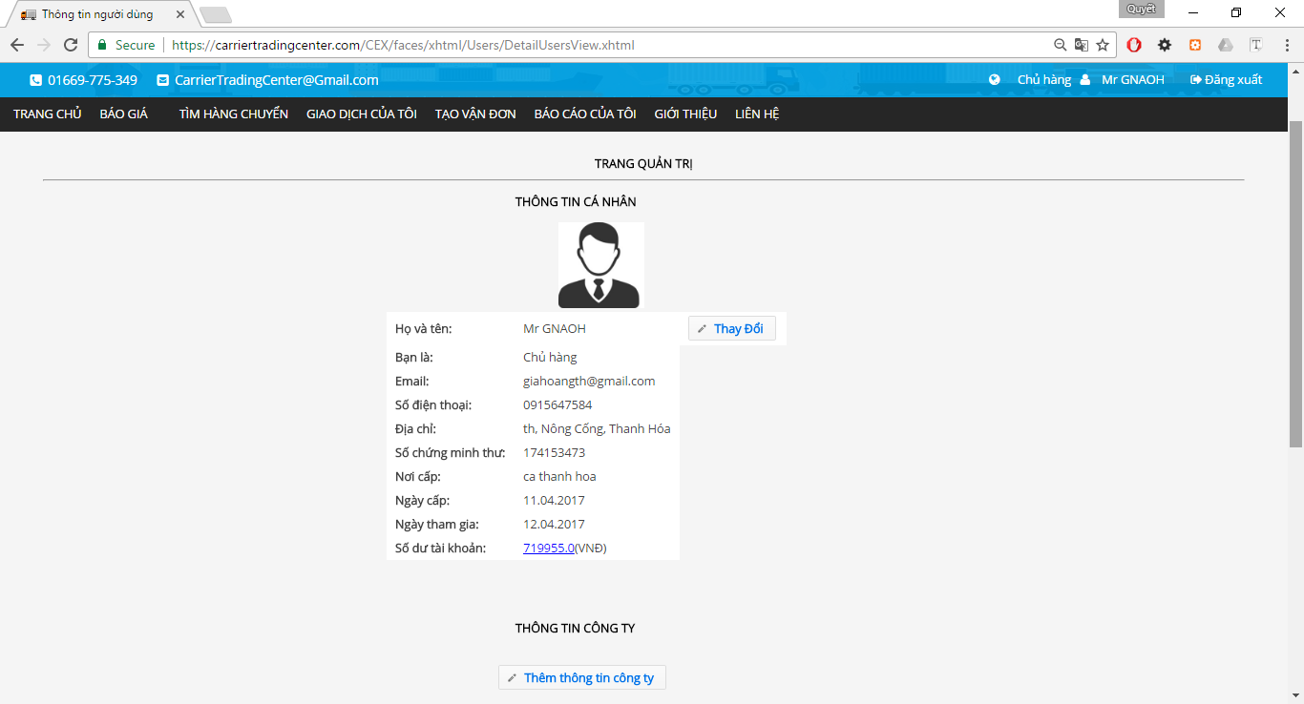

Figure 110 User Profile

**Table 2-15** User profile

|  |  |  |  |  |  |  |
| --- | --- | --- | --- | --- | --- | --- |
| **No** | **Object/Control Name** | **Object/Control Name in English** | **Type** | **Required** | **Length** | **Description** |
| 1. 11 | Thông tin cá nhân | userDeatilInformation | panelGrid | Yes |  |  |
| 2 | Thông tin công ty | companyInformation | panelGrid | No |  |  |
|  | Thay đổi |  | commandButton |  |  |  |
|  | Thêm thông tin công ty. |  | commandButton |  |  |  |

#### Case Exist Company Information

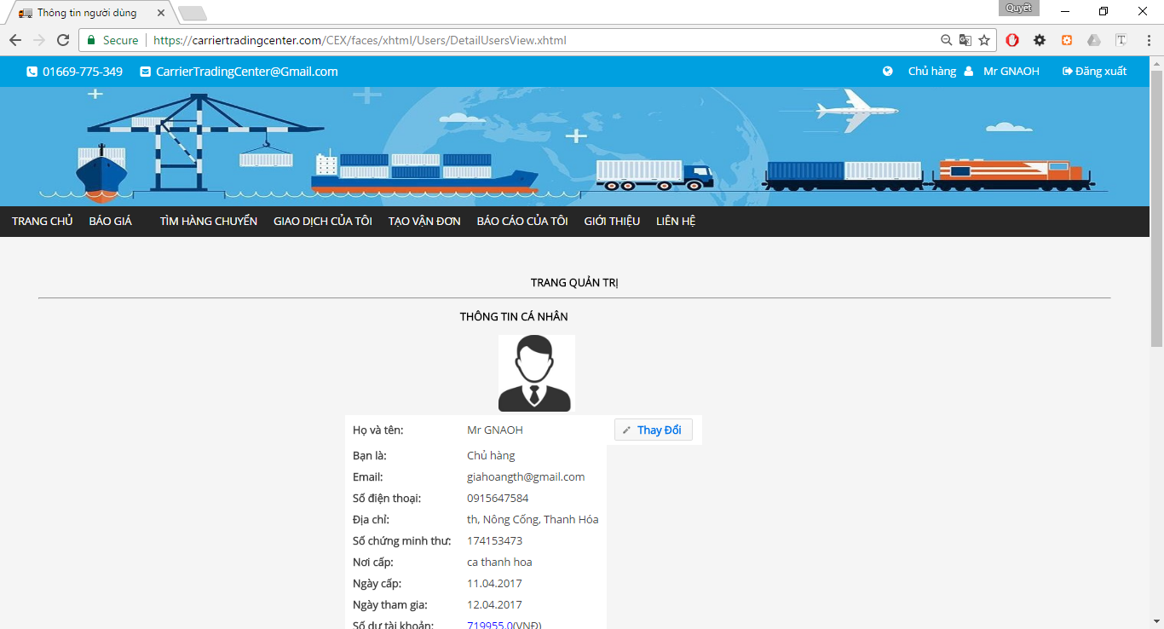

Figure 111 User Profile (part 1)

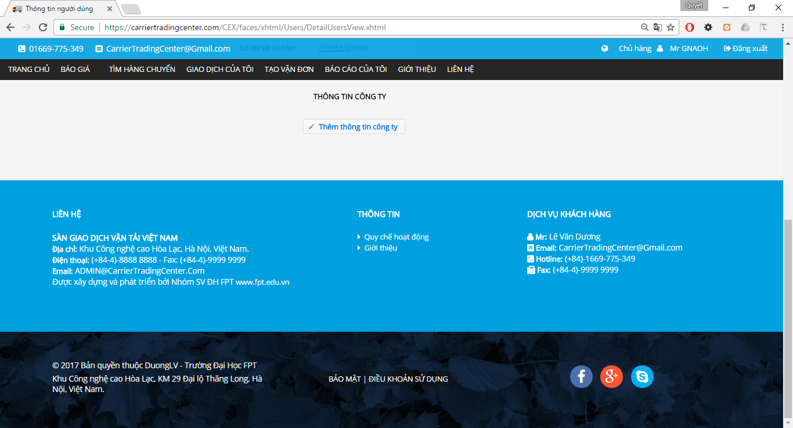

Figure 112 User Profile (part 2)

**Table 2-46** User profile

|  |  |  |  |  |  |  |
| --- | --- | --- | --- | --- | --- | --- |
| **No** | **Object/Control Name** | **Object/Control Name in English** | **Type** | **Required** | **Length** | **Description** |
| 1. 11 | Thông tin cá nhân | userDeatilInformation | panelGrid | Yes |  |  |
| 2 | Thông tin công ty | companyInformation | panelGrid | No |  |  |
|  | Thay đổi |  | commandButton |  |  |  |
|  | Thay đổi |  | commandButton |  |  |  |

### Sequence Diagram



Figure 113 User Profile Sequence Diagram

## Goods owner view report list

### Class Diagram



Figure 114 View Report list

### Class Description

#### ReportBean

|  |  |  |  |  |
| --- | --- | --- | --- | --- |
| Class | ReportBean | | | |
| **Description** | Show Operation fee. | | | |
| **Base Class** | BaseBean | | | |
| **Constructor** | N/A | | | |
| **Prototype** | N/A | | | |
| **Source File** | ReportBean.java | | | |
| **Namespace** | vn.co.cex.bean.report | | | |
| **Attributes** | Name | Type | Description | |
| userName | String |  | |
| fullName | String |  | |
| reportTitle | String |  | |
| reportContent | String |  | |
| reportReply | String |  | |
| status | boolean |  | |
| **Methods** | Name | Input | Output | Description |
| searchReportForAdmin() |  |  |  |

### Screen Design



Figure 115 List Report

**Table 2-47** User profile

|  |  |  |  |  |  |  |
| --- | --- | --- | --- | --- | --- | --- |
| **No** | **Object/Control Name** | **Object/Control Name in English** | **Type** | **Required** | **Length** | **Description** |
|  | Hỗ trợ tìm kiếm |  | panelGrid |  |  |  |
|  | Tiêu đề báo cáo | reportTitle | inputText | No | 75 |  |
|  | Từ ngày | reportDateBegin | calendar | No |  |  |
|  | Đén ngày | reportDateEnd | calendar | No |  |  |
|  | Tìm kiếm | search | commandButton |  |  |  |
|  | Danh sách bảo cáo | litsReport | dataTable |  |  |  |

### Sequence Diagram



Figure 116 List Report Sequence Diagram

## Goods owner search report

### Class Diagram



Figure 117 Search Report Class Diagram

### Class Description

#### ReportBean

|  |  |  |  |  |
| --- | --- | --- | --- | --- |
| Class | ReportBean | | | |
| **Description** | Show Operation fee. | | | |
| **Base Class** | BaseBean | | | |
| **Constructor** | N/A | | | |
| **Prototype** | N/A | | | |
| **Source File** | ReportBean.java | | | |
| **Namespace** | vn.co.cex.bean.report | | | |
| **Attributes** | Name | Type | Description | |
| userName | String |  | |
| fullName | String |  | |
| reportTitle | String |  | |
| reportContent | String |  | |
| reportReply | String |  | |
| status | boolean |  | |
| **Methods** | Name | Input | Output | Description |
| searchReportForAdmin() |  |  |  |

### Screen Design



Figure 118 Search Report

**Table 2-48** Search report

|  |  |  |  |  |  |  |
| --- | --- | --- | --- | --- | --- | --- |
| **No** | **Object/Control Name** | **Object/Control Name in English** | **Type** | **Required** | **Length** | **Description** |
|  | Hỗ trợ tìm kiếm |  | panelGrid |  |  |  |
|  | Tiêu đề báo cáo | reportTitle | inputText | No | 75 |  |
|  | Từ ngày | reportDateBegin | calendar | No |  |  |
|  | Đén ngày | reportDateEnd | calendar | No |  |  |
|  | Tìm kiếm | search | commandButton |  |  |  |
|  | Danh sách bảo cáo | litsReport | dataTable |  |  |  |

### Sequence Diagram



Figure 119 Search Report Sequence Diagram

## Goods owner comment to carrier

### Class Diagram



Figure 120 Comment to carrier Class Diagram

### Class Description

#### BillOfLadingDetailBean

|  |  |  |  |  |
| --- | --- | --- | --- | --- |
| Class | BillOfLadingDetailBean | | | |
| **Description** | Show detail bill of lading. | | | |
| **Base Class** | BaseBean | | | |
| **Constructor** | N/A | | | |
| **Prototype** | N/A | | | |
| **Source File** | BillOfLadingDetailBean.java | | | |
| **Namespace** | vn.co.cex.bean.billoflading | | | |
| **Methods** | Name | Input | Output | Description |
| auction(int) | billofLadingId |  |  |
| goodsOwnerCancelAuction() |  |  |  |
| carrierCancelAuction() |  |  |  |
| confirmCompleted() |  |  |  |
| writeComment() |  |  |  |
| writeAnswerComment(int) | commentId |  |  |
| updateComment() |  |  |  |

### Screen Design



Figure 121 Write comment

**Table 2-49** Write comment

|  |  |  |  |  |  |  |
| --- | --- | --- | --- | --- | --- | --- |
| **No** | **Object/Control Name** | **Object/Control Name in English** | **Type** | **Required** | **Length** | **Description** |
| 1. 11 | Hỏi đáp | questionAnswer | panelGroup |  |  |  |
| 2 | Button Send | send | commandButton |  |  |  |

### Sequence Diagram



Figure 122 Write comment to Carrier Sequence Diagram

## Goods owner answer to carrier

### Class Diagram



Figure 123 Answer to carrier

### Class Description

#### BillOfLadingDetailBean

|  |  |  |  |  |
| --- | --- | --- | --- | --- |
| Class | BillOfLadingDetailBean | | | |
| **Description** | Show detail bill of lading. | | | |
| **Base Class** | BaseBean | | | |
| **Constructor** | N/A | | | |
| **Prototype** | N/A | | | |
| **Source File** | BillOfLadingDetailBean.java | | | |
| **Namespace** | vn.co.cex.bean.billoflading | | | |
| **Methods** | Name | Input | Output | Description |
| auction(int) | billofLadingId |  |  |
| goodsOwnerCancelAuction() |  |  |  |
| carrierCancelAuction() |  |  |  |
| confirmCompleted() |  |  |  |
| writeComment() |  |  |  |
| writeAnswerComment(int) | commentId |  |  |
| updateComment() |  |  |  |

### Screen Design

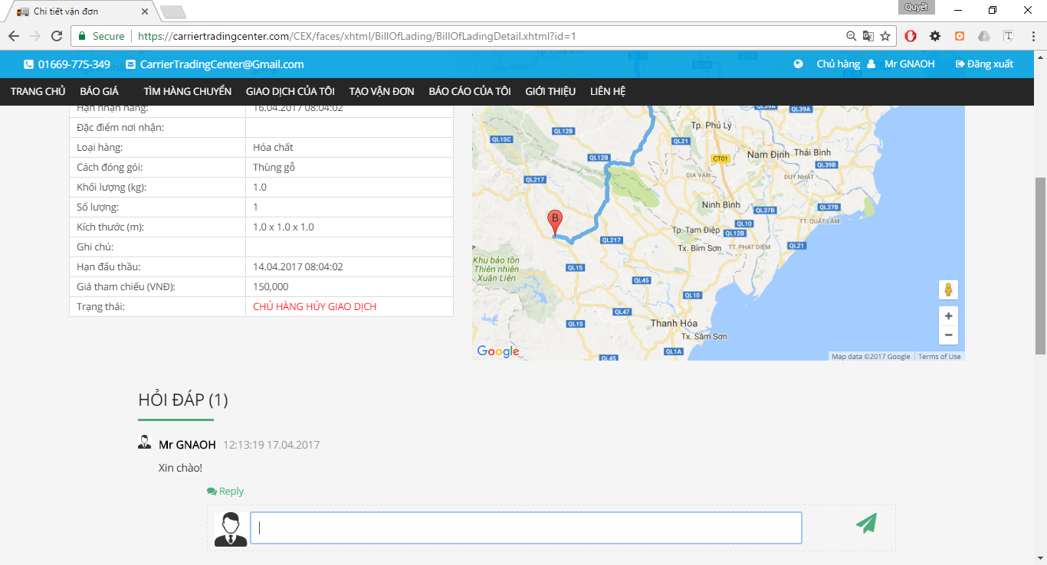

Figure 124

**Table 2-50** Answer comment

|  |  |  |  |  |  |  |
| --- | --- | --- | --- | --- | --- | --- |
| **No** | **Object/Control Name** | **Object/Control Name in English** | **Type** | **Required** | **Length** | **Description** |
| 1. 11 | Hỏi đáp | questionAnswer | panelGroup |  |  |  |
|  | Trả lời | reply | inputText |  |  |  |
| 2 | Button Send | send | commandButton |  |  |  |

### Sequence Diagram



Figure 125 Answer comment Sequence Diagram

## Goods owner account recharge

### Class Diagram



Figure 126 Goods Owner Account Recharge Class Diagram

### Class Description

#### NganLuongBean

|  |  |  |  |  |
| --- | --- | --- | --- | --- |
| Class | NganLuongBean | | | |
| **Description** | Account recharge through Ngan Luong. | | | |
| **Base Class** | BaseBean | | | |
| **Constructor** | N/A | | | |
| **Prototype** | N/A | | | |
| **Source File** | NganLuongBean.java | | | |
| **Namespace** | vn.co.cex.bean | | | |
| **Attributes** | Name | Type | Description | |
| link_checkout | String |  | |
| order_code | String |  | |
| token_code | String |  | |
| result | boolean |  | |
| balance | Float |  | |
| email | String |  | |
| fullname | String |  | |
| **Methods** | Name | Input | Output | Description |
| onPlusMoneyAccount() |  |  |  |
| sentRequest () |  |  |  |

### Screen Design



Figure 127 Account Recharge

**Table 2-51** Ngan Luong API

|  |  |  |  |  |  |  |
| --- | --- | --- | --- | --- | --- | --- |
| **No** | **Object/Control Name** | **Object/Control Name in English** | **Type** | **Required** | **Length** | **Description** |
| 1. 11 | Nạp tiền vào tài khoản | accountRecharge | NganLuong API |  |  |  |

### Sequence Diagram



Figure 128 Account Recharge Sequence Diagram

## Goods owner reference price

### Class Diagram

### Class Description

### Screen Design

### Sequence Diagram

## Goods owner confirm complete transaction

### Class Diagram



Figure 129 Confirm Complete Transaction Class Diagram

### Class Description

#### BillOfLadingDetailBean

|  |  |  |  |  |
| --- | --- | --- | --- | --- |
| Class | BillOfLadingDetailBean | | | |
| **Description** | Show detail bill of lading. | | | |
| **Base Class** | BaseBean | | | |
| **Constructor** | N/A | | | |
| **Prototype** | N/A | | | |
| **Source File** | BillOfLadingDetailBean.java | | | |
| **Namespace** | vn.co.cex.bean.billoflading | | | |
| **Methods** | Name | Input | Output | Description |
| auction(int) | billofLadingId |  |  |
| goodsOwnerCancelAuction() |  |  |  |
| carrierCancelAuction() |  |  |  |
| confirmCompleted() |  |  |  |
| writeComment() |  |  |  |
| writeAnswerComment(int) | commentId |  |  |

### Screen Design



Figure 130 Confirm Dialog

**Table 2-51** Comfirm transaction

|  |  |  |  |  |  |  |
| --- | --- | --- | --- | --- | --- | --- |
| **No** | **Object/Control Name** | **Object/Control Name in English** | **Type** | **Required** | **Length** | **Description** |
| 1. 11 | Xác nhận | confirm | commandButton |  |  |  |
|  | Hủy bỏ | cancel | commandButton |  |  |  |

### Sequence Diagram



Figure 131 Confirm Complete Transaction Sequence Diagram

## Goods owner add company

### Class Diagram



Figure 132 Goods Owner Add Company Class Diagram

### Class Description

#### UserDetailBean

|  |  |  |  |  |
| --- | --- | --- | --- | --- |
| Class | OperationFeeBean | | | |
| **Description** | Show bill of lading and search bill of lading. | | | |
| **Base Class** | BaseBean | | | |
| **Constructor** | N/A | | | |
| **Prototype** | N/A | | | |
| **Source File** | UsersDetailBean.java | | | |
| **Namespace** | vn.co.cex.bean.users | | | |
| **Attributes** | Name | Name | Name | |
| name | String | name | |
| taxCode | String | taxCode | |
| email | String | email | |
| phoneNumber | String | phoneNumber | |
| fax | String | fax | |
| filename | String | filename | |
| districtName | String | districtName | |
| provinceName | String | provinceName | |
| address | String | address | |
| issuccess | bolean | issuccess | |
| amount | Float | amount | |
| **Methods** | Name | Input | Output | Description |
| addCompany() |  |  |  |

### Screen Design

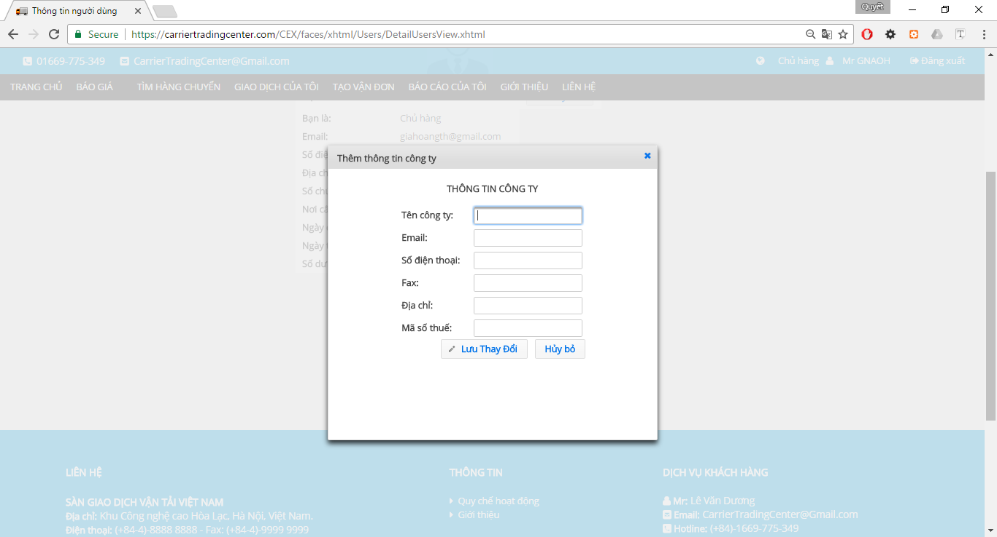

Figure 133 Add Company

**Table 2-33** Add Company

|  |  |  |  |  |  |  |
| --- | --- | --- | --- | --- | --- | --- |
| **No** | **Object/Control Name** | **Object/Control Name in English** | **Type** | **Required** | **Length** | **Description** |
|  | Thông tin công ty | companyInformation | panelGrid |  |  |  |
|  | Tên công ty | comapnyName | inputText |  | 100 |  |
|  | Email | email | inputText |  | 50 |  |
|  | Số điện thoại | phoneNumber | inputText |  | 11 |  |
|  | Fax | fax | inputText |  | 20 |  |
|  | Địa chỉ | address | inputText |  | 100 |  |
| 1. 11 | Mã số thuế | taxCode | inputText |  | 20 |  |
|  | Lưu thay đổi | confirm | commandButton |  |  |  |
|  | Hủy bỏ | cancel | commandButton |  |  |  |

### Sequence Diagram



Figure 134 Add Company Information Sequence Diagram

## Carrier view list bill of lading

### Class Diagram



Figure 135 View List Bill of Lading

### Class Description

#### CommonBean

|  |  |  |  |  |
| --- | --- | --- | --- | --- |
| Class | CommonBean | | | |
| **Description** | Show bill of lading and search bill of lading. | | | |
| **Base Class** | BaseBean | | | |
| **Constructor** | N/A | | | |
| **Prototype** | N/A | | | |
| **Source File** | CommonBean.java | | | |
| **Namespace** | vn.co.cex.bean.billoflading | | | |
| **Attributes** | Name | Type | Description | |
| goodsTypeId | Integer |  | |
| packagedFormId | Integer |  | |
| weight | Float |  | |
| volume | Float |  | |
| departureProvinceCode | String |  | |
| arrivalProvinceCode | String |  | |
| status | Integer |  | |
| timeRemaining | int |  | |
| **Methods** | Name | Input | Output | Description |
| searchBillOfLading() |  |  |  |

### Screen Design

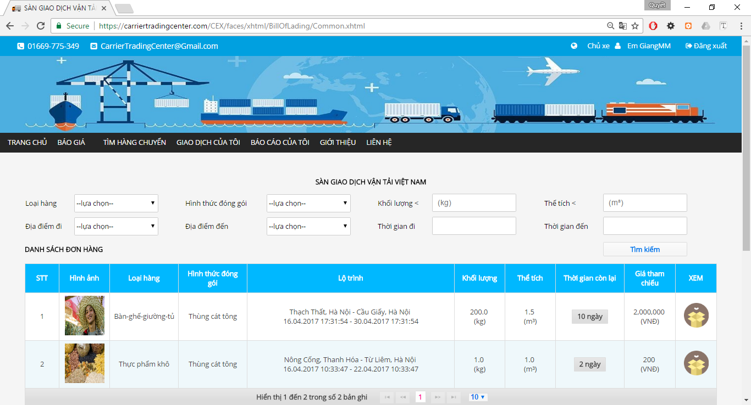

Figure 136 List Bills of Lading

**Table 2-55** Bills of Lading

|  |  |  |  |  |  |  |
| --- | --- | --- | --- | --- | --- | --- |
| **No** | **Object/Control Name** | **Object/Control Name in English** | **Type** | **Required** | **Length** | **Description** |
| 1. 11 | Loại Hàng | goodTypeId | selectOneMenu | No |  |  |
| 2 | Hình thức đóng gói | packageFormId | selectOneMenu | No |  |  |
| 3 | Khối lượng | weight | inputText | No |  |  |
|  | Thể tích | volume | inputText | No |  |  |
|  | Địa điểm đi | slbDepartureProvinceID | selectOneMenu | No |  |  |
|  | Địa điêm đến | slbArrivalProvinceID | selectOneMenu | No |  |  |
|  | Thời gian đi | departureDate | calendar | No |  |  |
|  | Thời gian đến | arrivalDate | calendar | No |  |  |
|  | Tìm kiếm | search | commandButton |  |  |  |
|  | Danh sách đơn hàng | table_billoflading | dataTable |  |  |  |

### Sequence Diagram



Figure 137 List Bill of Lading Sequence Diagram

## Carrier view bill of lading detail

### Class Diagram

### Class Description

### Screen Design

### Sequence Diagram

## Carrier auction bill of lading

### Class Diagram



Figure 138 Auction Bill of Lading Class Diagram

### Class Description

#### BillOfLadingDetailBean

|  |  |  |  |  |
| --- | --- | --- | --- | --- |
| Class | BillOfLadingDetailBean | | | |
| **Description** | Show detail bill of lading. | | | |
| **Base Class** | BaseBean | | | |
| **Constructor** | N/A | | | |
| **Prototype** | N/A | | | |
| **Source File** | BillOfLadingDetailBean.java | | | |
| **Namespace** | vn.co.cex.bean.billoflading | | | |
| **Methods** | Name | Input | Output | Description |
| auction(int) | billofLadingId |  |  |
| goodsOwnerCancelAuction() |  |  |  |
| carrierCancelAuction() |  |  |  |
| confirmCompleted() |  |  |  |
| writeComment() |  |  |  |
| writeAnswerComment(int) | commentId |  |  |

### Screen Design



Figure 139 Auction Bills of Lading

**Table 2-57** Auction Bills of Lading

|  |  |  |  |  |  |  |
| --- | --- | --- | --- | --- | --- | --- |
| **No** | **Object/Control Name** | **Object/Control Name in English** | **Type** | **Required** | **Length** | **Description** |
| 1. 11 | Thông tin hàng hóa cần vận chuyển | good_information | panelGrid |  |  |  |
| 2 | Gmap | gmap | Java script |  |  |  |
| 3 | Đấu thầu | auction | commandButton |  |  |  |

### Sequence Diagram



Figure 140 Auction Bill of Lading Sequence Diagram

## Carrier account recharge

### Class Diagram



Figure 141 Account Recharge Class Diagram

### Class Description

#### NganLuongBean

|  |  |  |  |  |
| --- | --- | --- | --- | --- |
| Class | NganLuongBean | | | |
| **Description** | Account recharge through Ngan Luong. | | | |
| **Base Class** | BaseBean | | | |
| **Constructor** | N/A | | | |
| **Prototype** | N/A | | | |
| **Source File** | NganLuongBean.java | | | |
| **Namespace** | vn.co.cex.bean | | | |
| **Attributes** | Name | Type | Description | |
| link_checkout | String |  | |
| order_code | String |  | |
| token_code | String |  | |
| result | boolean |  | |
| balance | Float |  | |
| email | String |  | |
| fullname | String |  | |
| **Methods** | Name | Input | Output | Description |
| onPlusMoneyAccount() |  |  |  |
| sentRequest () |  |  |  |

### Screen Design



Figure 142 Account Recharge

**Table 2-58** Ngan Luong API

|  |  |  |  |  |  |  |
| --- | --- | --- | --- | --- | --- | --- |
| **No** | **Object/Control Name** | **Object/Control Name in English** | **Type** | **Required** | **Length** | **Description** |
| 1. 11 | Nạp tiền vào tài khoản | accountRecharge | NganLuong API |  |  |  |

### Sequence Diagram



Figure 143 Account Recharge Sequence Diagram

## Carrier search bill of lading

### Class Diagram



Figure 144 Search Bill of Lading Class Diagram

### Class Description

#### CommonBean

|  |  |  |  |  |
| --- | --- | --- | --- | --- |
| Class | CommonBean | | | |
| **Description** | Show bill of lading and search bill of lading. | | | |
| **Base Class** | BaseBean | | | |
| **Constructor** | N/A | | | |
| **Prototype** | N/A | | | |
| **Source File** | CommonBean.java | | | |
| **Namespace** | vn.co.cex.bean.billoflading | | | |
| **Attributes** | Name | Type | Description | |
| goodsTypeId | Integer |  | |
| packagedFormId | Integer |  | |
| weight | Float |  | |
| volume | Float |  | |
| departureProvinceCode | String |  | |
| arrivalProvinceCode | String |  | |
| status | Integer |  | |
| timeRemaining | int |  | |
| **Methods** | Name | Input | Output | Description |
| searchBillOfLading() |  |  |  |

### Screen Design



Figure 145 Search Bills of lading

**Table 2-59** Searchbills of lading

|  |  |  |  |  |  |  |
| --- | --- | --- | --- | --- | --- | --- |
| **No** | **Object/Control Name** | **Object/Control Name in English** | **Type** | **Required** | **Length** | **Description** |
| 1. 11 | Loại Hàng | goodTypeId | selectOneMenu | No |  |  |
| 2 | Hình thức đóng gói | packageFormId | selectOneMenu | No |  |  |
| 3 | Khối lượng | weight | inputText | No |  |  |
|  | Thể tích | volume | inputText | No |  |  |
|  | Địa điểm đi | slbDepartureProvinceID | selectOneMenu | No |  |  |
|  | Địa điêm đến | slbArrivalProvinceID | selectOneMenu | No |  |  |
|  | Thời gian đi | departureDate | calendar | No |  |  |
|  | Thời gian đến | arrivalDate | calendar | No |  |  |

### Sequence Diagram



Figure 146 Search Bill of Lading Sequence Diagram

## Carrier cancel bill of lading

### Class Diagram



Figure 147 Cancel Bill of Lading Class Diagram

### Class Description

#### BillOfLadingDetailBean

|  |  |  |  |  |
| --- | --- | --- | --- | --- |
| Class | BillOfLadingDetailBean | | | |
| **Description** | Show detail bill of lading. | | | |
| **Base Class** | BaseBean | | | |
| **Constructor** | N/A | | | |
| **Prototype** | N/A | | | |
| **Source File** | BillOfLadingDetailBean.java | | | |
| **Namespace** | vn.co.cex.bean.billoflading | | | |
| **Methods** | Name | Input | Output | Description |
| auction(int) | billofLadingId |  |  |
| goodsOwnerCancelAuction() |  |  |  |
| carrierCancelAuction() |  |  |  |
| confirmCompleted() |  |  |  |
| writeComment() |  |  |  |
| writeAnswerComment(int) | commentId |  |  |

### Screen Design



Figure 148 Cancel Bill of Lading

**Table 2-60** Detail Bills of Lading

|  |  |  |  |  |  |  |
| --- | --- | --- | --- | --- | --- | --- |
| **No** | **Object/Control Name** | **Object/Control Name in English** | **Type** | **Required** | **Length** | **Description** |
| 1. 11 | Thông tin hàng hóa cần vận chuyển | good_information | panelGrid |  |  |  |
| 2 | Gmap | gmap | Java script |  |  |  |
|  | Hủy đấu thầu | cancelBillOfLading | commandButton |  |  |  |

### Sequence Diagram



## Carrier

### Class Diagram

### Class Description

### Screen Design

### Sequence Diagram

## Carrier

### Class Diagram

### Class Description

### Screen Design

### Sequence Diagram

## Carrier

### Class Diagram

### Class Description

### Screen Design

### Sequence Diagram

## Carrier

### Class Diagram

### Class Description

### Screen Design

### Sequence Diagram

## Carrier

### Class Diagram

### Class Description

### Screen Design

### Sequence Diagram

## Carrier

### Class Diagram

### Class Description

### Screen Design

### Sequence Diagram

## Carrier

### Class Diagram

### Class Description

### Screen Design

### Sequence Diagram

## Carrier

### Class Diagram

### Class Description

### Screen Design

### Sequence Diagram

# DATABASE DESIGN

## Entity Relationship Diagram

## Database Diagram

## Table Descriptions

### Table xxx

|  |  |  |  |  |
| --- | --- | --- | --- | --- |
| No. | Attribute | Type | Constraints | Description |
| 1 |  |  |  |  |
| 2 |  |  |  |  |
| 3 |  |  |  |  |

### Table xxx

|  |  |  |  |  |
| --- | --- | --- | --- | --- |
| No. | Attribute | Type | Constraints | Description |
| 1 |  |  |  |  |
| 2 |  |  |  |  |
| 3 |  |  |  |  |
| 4 |  |  |  |  |
| 5 |  |  |  |  |
| 6 |  |  |  |  |
| 7 |  |  |  |  |
| 8 |  |  |  |  |
| 9 |  |  |  |  |
| 10 |  |  |  |  |
| 11 |  |  |  |  |
| 12 |  |  |  |  |
| 13 |  |  |  |  |
| 14 |  |  |  |  |
| 15 |  |  |  |  |